D1.3
REINFORCE Project Handbook
Including quality guidelines and ethical guidelines

Date | 6.03.2020
Dissemination Level | Public
Responsible Partner | EGO
Editors | Stavros Katsanevas
Authors | Claudia M. Fabian,

DOCUMENT HISTORY  Version Date |  | Contributor | Comments
0.1 | 06/03/2020 | Stavros Katsanevas | First draft
0.2
0.3
0.4
1.0

Legal Notices
The information in this document is subject to change without notice.
The Members of the REINFORCE Consortium make no warranty of any kind with regard to this document, including, but not limited to, the implied warranties of merchantability and fitness for a particular purpose. The Members of the REINFORCE Consortium shall not be held liable for errors contained herein or direct, indirect, special, incidental or consequential damages in connection with the furnishing, performance, or use of this material.
REINFORCE is a collaborative research project funded by the European Commission under the Research and Innovation Infrastructures programme of Horizon 2020 grant agreement nr. XXXXX. This report reflects the views only of the authors, and the Commission cannot be held responsible for any use which may be made of the information contained therein.
Contents

List of Figures 5
List of Tables 5
List of Abbreviations 5
Executive summary 6
1 Introduction 6
2 Management structure 7
2.1 Consortium agreement 11
2.2 REINFORCE Advisory Board 11
3 Quality procedures 12
3.1 Internal communication structures 13
3.2 External communication structures 13
3.3 Quality of deliverables and peer review 16
3.4 Regular internal surveys 19
3.5 Risk management 19
3.6 SWOT 20
3.7 Glossary/Definition of core concepts 21
3.8 Project templates 22
4 Tools and collaboration infrastructure 22
5 Responsible Research and Innovation (RRI) 23
6 Ethical guidelines 24
6.1 Data protection and privacy 24
6.2 Communication strategy 25
6.3 Informed consent 25
6.4 Relevant regulations and scientific standards 25
6.5 Privacy aspects as part of REINFORCE research 26
7 Open source and open access strategy 27
7.1 Open source strategy 27
7.2 Open access 28
8 Conclusion 28
9 References 29
Annex I: Checklist for deliverables 30
Annex II: Peer review template 31
Annex III: Project management survey 33
Annex IV: Confidentiality agreement 35
Annex V: Data exchange form 36
Annex VI: Informed consent form for research participant 37
Annex VII: Informed consent form for community of practice 38
Annex VIII: Project Information Sheet 40

List of Figures
Figure 1: Project Management Structure 11
Figure 2: Associate Partner Network 16
Figure 3: Associate Partner Network Membership Process 17
Figure 4: Peer review process 21
Figure 5: SWOT Matrix 23

List of Tables
Table 1: Project Committee 12
Table 2: General Assembly members 14
Table 3: Advisory Board members 14

List of Abbreviations

APN Associate Partner Network
DOW Description of Work
EC Ethics Committee
PMB Project Management Board
PU Public
RE Restricted
RRI Responsible Research and Innovation
VOIP Voice over IP
WP Work package
WPL Work package leader

…..

Executive summary
This updated Project Handbook describes the internal procedures of the REINFORCE consortium in terms of management structures, communication and collaboration as well as quality control measures. It also defines the way the partners are performing responsible research and dealing with ethical issues, especially related to personal data collection, analysis and storage. In addition the open source and open access strategy of the consortium is reflected in this document.
The main target group for this deliverable remain the consortium partners themselves as this handbook defines the project internal processes for securing high quality research work to be performed across a set of complementary partner institutions. In addition to this document version the handbook is included in the project wiki, where continuous updates are made in order to further improve internal processes.

Introduction
The REINFORCE project is committed to high quality output and responsible research and innovation. Thus this document defines a set of procedures that the consortium is committed to adhere to and to improve in the course of the project.
Openness and transparency are two of the guiding principles that the reader will see reflected in the different processes and methods described. At the same time there is a strong awareness within the consortium related to privacy and data protection of individual citizens. These core principles underlying the research work in REINFORCE correspond with the practices related to Responsible Research and Innovation.
Section 2 below describes the management structures. Section 3 is dedicated to specific quality management procedures, including communication structures and tools as well as the peer reviewing process for high quality deliverables. In Section 4 the technical infrastructure for communication and collaboration is presented. Section 5 has been added to the handbook to present the RRI policies and identify the most relevant aspects for REINFORCE while Section 6 outlines the specific ethical guidelines that the project is following. In Section 7 the consortium’s strategy towards openness is described and relates to open source in terms of software as well as open access in terms of publications and other project results.
Finally the appendix includes examples of updated templates mentioned throughout the project.

Management structure
REINFORCE is a large-­‐scale project with a broad scope in topics, partners and regions. Therefore, the management structure and procedures work in a flexible manner in order to:
  - Achieve integration of all consortium members and to mobilise their expertise, knowledge and networks in every stage of the project
  - Efficiently coordinate the processing of the work plan in a collaborative environment
  - Continuously involve contextual expertise and knowledge of relevant practitioners and their networks
Our approach is a combination of integration and decentralisation strategies. Integration is achieved through the composition of a consortium with complementary skills and knowledge, the development of a joint framework, the agreement on common guidelines for theoretical and empirical analyses, the joint work on the comparative analysis and the synthesis, and project workshops and meetings. The resources of all partners will be mobilised by decentralisation of responsibilities through the assignment of leadership for work packages and defined work package tasks with a clear task sharing based on the different competence fields of the partners.
The management structure defines the basic roles and responsibilities. The Project Coordinator (PC, Stavros Katsanevas) is responsible for the overall line of actions and the day-­‐to-­‐day management carried out by the project. The Project Coordinator is supported by the Deputy Project Coordinator (DPC, Emmanuel Chaniotakis), the Project Officer (Francesca Spagnuolo) and a Technical Coordinator (TC, Garry Hemming) and who manages the project scientific work and technical development from a strategic point. A financial manager and an administrative employee, from EGO support the coordinator
Other key officers are the Ethics Manager (EM, Margit ) the Innovation Manager (IM, Francesco Mureddu) and the Quality Manager (QM, Christian Olivetto). We develop further the definition of the 3 roles below:
- Project Officer (PO). REINFORCE has set-up a Project Office to coordinate the administration of the project. The relevant activities of the Project Office include; assisting and facilitating the work of the PC for executing the decisions of the GA as well as the day-to-day management of the project, supporting partners in administrative matters, assisting in the communication and collaboration setting-up, running and maintenance of the project, organising and assisting the running and following up of project meetings, follow scheduling of reports and deliverables, maintaining the schedule, establishing and maintaining financial plan, monitoring and reporting, coordination of costs submission, preliminary checks of individual costs and consolidation of cost, following-up of EC payments, distributing partner shares according to consortium agreement rules, providing financial helpdesk services.
- Innovation Manager (IM) The role of the IM is to identify emerging market opportunities, assure that the project’s results are exploitable and disseminated effectively and address the issues faced by the relevant markets. The IM has to pursue the realization of standardization activities with the help of the consortium and in cooperation with the relevant standardization bodies, while being able to recognize technical and market-related drivers and barriers to adoption and develop strategies to exploit and overcome these, respectively.
- Ethics Manager (EM). The Ethics Committee (EC), steered by the Ethics Manager, oversees ensuring compliance with regulations and ethical principles. It supervises privacy and data protection compliance and monitors the adherence of the results of the trials, where final users will be involved, to the ethical principles that will be defined at the very beginning of the project. The ETC of REINFORCE will be formed from the Ethics Manager and the representatives of EA and EGO.

Each work package has been appointed a Work Package Leader, who is responsible for the progress within the work package and who is supported by task leaders and other members of the consortium involved in each of the WPs. Clear responsibilities (based on the competences of each partner) are described in the Work Package Description.
The Governance of REINFORCE further consists of the following 4 committees :
- General Assembly (GA) providing strategic and vision guidance to REINFORCE. It is composed of the PC/DPC + 10 partners and it convenes every 6 months
- Project Committee (PC) taking over administrative, financial and overall coordination. PC secures the monitoring and control of the project in terms of resources, cost, milestones and deliverables in line with what has been planned and the approval for the financial plan and work plan for the coming project period the PMC reports to the GA. It is composed of the PC/DPC/TM, the WP Leaders, the PO, the IM and the QM and it convenes every month.
- Project Technical Committee (PTC) undertaking the technical coordination of the project, where WPs are reviewed, and results are consolidated. The role of the PTC is (a) to review the work plan progress; (b) to coordinate the preparation and distribution of all major technical deliverables, to ensure technical consistency and maximum synergy between WPs and high quality of deliverables... The PTC reports to the PMC. It is composed of the TM, the DPC, the WP leaders, the IM and QM and it convenes every 2 months
- Advisory Board (AB). The AB, led by OU, is an external group of valued and recognized experts, representing the industry and the end-users. The AB can provide valuable insights and advice on the strategic direction of the project, and in general on key technical, business and market matters. The AB will support the consortium with directions on dissemination and exploitation actions, the definition of the communication strategy and the liaison with other H2020 projects or global initiatives. It convenes once a year. The Advisor Board is lead by the Advisory Board Coordinator (ABC, Stephen Serjeant) who also assures external relations and follows the advices of the Advisory Board Councelor (Wanda Merced-Diaz).
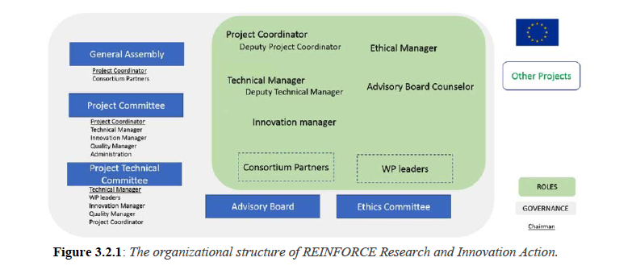
Figure 1: Project Management Structure
The project is managed through the Project Committee (PC). It provides the overall direction for the project, both strategic and operational. The PC maintains the project directions and obtains advice from the Work Package Leaders, to ensure that the project meets its stated and implied goals. The PC ultimately supervises all project management processes, including initiation, planning, execution, control, and closure of project phases. Within this framework, the Work Package Leaders coordinate the detailed planning, execution and control of the technical tasks to meet the project’s scientific and technical objectives relevant to their work packages.
The PC is responsible for the proper execution and implementation of the decisions of the General Assembly and makes suggestions to the General Assembly on pending decision such as:
  - Accept or reject changes to the work plan, changes in the Grant Agreement and amendments to the Consortium Agreement
  - Make changes in the Project Management structure
The PMB is currently composed of the persons listed in Table 1 below:

Person | Organisati on | Role
Stavros Katsanevas | EGO | Project coordinator
Emmanuel Chaniotakis | EA | Deputy Coordinator
Gary Hemming | EGO | Technical Coordinator
Francesca Spagnuolo | EGO | WP1 Lead and Project Officer
Sofoklis Sotiriou | EA | WP2 Lead
Massimiliano Razzano | UNIPI | WP3 Lead
Paschal Coyle | CNRS | WP4 Lead
Christine Kourkoumelis | IASA | WP5 Lead
Jacques Marteau | CNRS | WP₆ Lead
Beatriz Garcia | CONICET | WP7 Lead
Emmanuel Chanitotakis | EA | WP8 Lead
Claudia Magdalena Fabian | ZSI | WP9 Lead
Francesco Mureddu | Trust-IT | WP10 Lead
Claudia Magdalena Fabian | ZSI | Ethics Manager (EM)
Francesco Mureddu | LC | Innovation Manager (IM)
Christian Olivetto | EGO | Quality Manager (QM)
Stephen Sergeant | OU | Advisory Board Coordinator (ABC)
Wanda Merced-Diaz | CONICET | Advisory Board Councelor

Table 1: Project Committee

Work package Leaders (WPL)
Each work package is coordinated by a Work Package Leader, to ensure the performance and progress of the work package regarding the overall work plan and provision of the work in progress. The WPL is in charge of the coordination of the different tasks and involved partners, as well as the gathering of material from all partners required to produce the reports according to the deliverable list and the work plan. WPLs have been appointed according to their specialisation, scientific expertise, and management skills (see list above). The WPLs are in regular contact with the coordinator to inform her about the on-­‐going and planned WP activities, and recent and future WP results and achievements. The responsibilities of the Work Package Leader are:
- Distributing and coordinating the different tasks among all participating consortium members
- Monitoring the progress of the WP according to time and budget allocations, ensuring that the WP fulfils the objectives listed as milestones and deliverables, alerting the coordinator in case of delay or default
- Delivering quarterly management reports to the coordinator for internal use
- Participating in the monthly REINFORCE’s meetings for keeping the consortium up to date and aligning activities

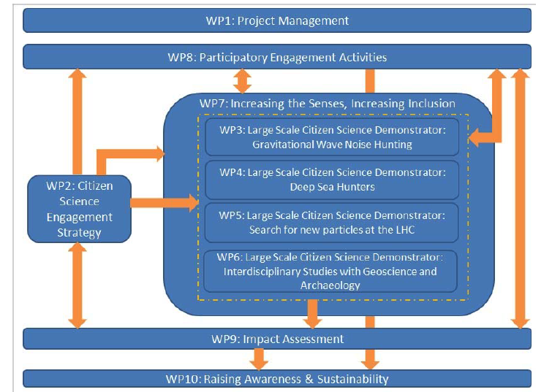

Figure 1.a . Work Package relationships
General Assembly
The General Assembly is the ultimate decision-­‐making body of the consortium and functions as highest authority, as last resort of all relevant project decisions. The body consists of one representative per partner. The following table lists the current members of the General Assembly:

Person | Organisation
Stavros Katsanevas | EGO
Sofoklis Sotiriou | EA
Christine Kourkoumelis | IASA
Beatriz Garcia | CONICET
Stephen Serjeant | OU
Elisabeth Unterfrauner | ZSI
Francesco Mureddu | LC
Massimiliano Razzano | UNIPI
Veronique Van Elewyck | CNRS/APC
Jacques Marteau | CNRS/IP2I
Paschal Coyle | CNRS/CPPM
Silvana Mucella | Trust-IT
Chris Lintott | UOXF

Table 2: Members of General Assembly

A face-­‐to-­‐face general assembly comprising all project consortium partners takes place at least once a year, to coordinate overall project work. Ad-­‐hoc meetings can be called in case of important decisions to be taken.
The Decision-Making and Conflict Resolution Process will be based on consent and transparency and shall be taken in a fair process. All decision-making bodies with the responsibilities described in the above (project management structure) section are committed to apply these fundamentals. In the course of the project the partners will have to agree on and develop technical, scientific and commercial ideas and specifications. The objective would be to reach agreement first by informal contact, followed by official confirmation via e-mail, letter or agreed written minutes. Decision will be taken at the level that is concerned, e.g. on WP level if decisions affect only the respective WP or will be escalated up to the GA if they have to do with fundamental changes in the work plan, consortium, etc. Any party which a member of a consortium body is (described above) should be represented at any meeting of such consortium body; may appoint a substitute or a proxy to attend and vote at any meeting; and shall participate in a cooperative manner in the meetings. Each consortium body shall not deliberate and decide validly unless two-thirds (2/3) of its members are present or represented quorum). If the quorum is not reached, the chairperson of the consortium body shall convene another ordinary meeting within 15 calendar days. If in this meeting the quorum is not reached once more, the chairperson shall convene an extraordinary meeting which shall be entitled to decide even if less than the quorum of Members is present or represented. Each member of a consortium body present or represented in the meeting shall have one vote. Defaulting parties may not vote. Decisions shall be taken by a majority of two-thirds (2/3) of the votes cast.
The REINFORCE project fully supports the European Union policy on equal opportunities between women and men. To this end, participation of women is high at all levels of the project, including management, and is continually encouraged and supported.

Consortium agreement
A consortium agreement will be signed by all partners during the first year. It defines the specific operational procedures for the different project bodies described above. This includes amongst other aspects the responsibilities of the parties and their liabilities towards each other as well as the governance structure, financial provision and IPR issues. The consortium agreement also describes the decision making structures and defines the General Assembly is the ultimate decision making body. Decisions taken by the General Assembly include the content, e.g. changes in the DoW, finances and intellectual property rights. This body also has the right to decide on the evolution of the partnership (e.g. entry of new partner), and the project as such (e.g. termination of the project).

REINFORCE Advisory Board
In addition to the internal structures for operating the project, the consortium agreed on establishing an REINFORCE Advisory Board consisting of seven project-­‐external experts in fields related to the project.
These experts are appointed to evaluate and comment the progress and outcomes of the project activities. Communication with the Board is taking place in face-­‐to-­‐face meetings as well as via videoconferences. Apart from their advisory role they are also project "Ambassadors" and promote the project within their respective networks. In particular with the other research infrastructures through ESCAPE.

Current members of this Board are:

Person | Organisation
Stephen Searjent | OU
Wanda Merced-Diaz | Texas
 | LSST
 | CTA
 | LISA
 | SKA
 | Discover the Cosmos

Table 3: Advisory Board Member

Quality procedures
Quality assurance is of high priority in collaborative research, such as REINFORCE, and the consortium is committed to a set of quality procedures to guarantee high quality project output. Measures to ensure good quality include e.g. the definition of internal communication structures, regular internal surveys for self-­‐assessment and a proper SWOT analysis as well as a defined peer review process for any project deliverable. The detailed procedures will be described in more detail in the following sections. In addition, WP1 will be closely monitoring the performance indicators defined for the project and report regularly on these to the Project Management Board and the project coordinator, who performs continuous monitoring and trigger quality assurance project reviews during the general assemblies.
A Quality Assurance Plan will be set up and maintained as part of the project management processes and will be described in the project management handbook. The quality management will define the following; Document control - management of printed and electronic documents (e.g. templates, structure, standard format, handling according to dissemination level, etc.); Reporting: harmonization with the reporting procedures of the EC, gathering information from all the partners for reporting (both technical and financial); Deliverables: instructions about the form and the way of writing the deliverables, review/acceptance of deliverables; Communication and exchange of information between the partners. The quality management will be supported by the document facility of the collaborative project management platform for producing deliverables.
Especially, regarding the acceptance of deliverables / peer review process; all project deliverables will be subject to acceptance by the following parties, in the order indicated: i) partner responsible for the deliverable (normally Task Leader); ii) WP Leader; iii) PTC; (iv) PC; v) GA and vii) EC.
All deliverables will be internally peer reviewed before their final submission. Depending on the deliverable’s scope and objectives the most appropriate experts coming from the consortium partners will be chosen. The Project Quality Management will be addressed by Quality Control and Management Assessment (WP1) and in particular the Quality Manager (QM)

Internal communication structures
Internal communication is first and foremost based on the concept of openness and transparency. An active communication strategy is implemented to establish a strong project identity in order to obtain maximum transparency for all partners involved, and to increase synergy in cooperation.
The project will use advanced ICT means, moreover, the project will hold various physical meetings hosted in turn by Partners. At least two to four general meetings are planned yearly to hold technical and planning sessions and guarantee consistency and integrity of the project. GA meetings will be held in this context. Additional workshops or meetings will be held as required by the work plan. Finally, a Collaboration and Real-time Communication Platform (provided by EA, https://fit- bscw.fit.fraunhofer.de/bscw/ ) is going to be used. This platform will provide a digital workspace to support the electronic communication and cooperation between project team members.
Daily communication among the WPs, the partners, etc. is established mainly through
    - e-­‐mails and a central mailing list including all project partners,
    - a project space (Wiki) for internal exchange of documents as well as offline communication,
    - web-­‐conferencing for regular online meetings, VOIP (e.g. Skype or SIP) or phone,
    - face-­‐to-­‐face communication (during physical project meetings),
    - online storage of all documents (deliverables, contract, etc.).
The consortium partners meet approximately every six months face-­‐to-­‐face (at synchronisation points) to coordinate the research process.
Each month, at least one virtual consortium meeting takes place via video conferencing. These meetings ensure the internal communication among partners, allow the WP Leaders/thematic leaders to coordinate the various tasks, and report the progress of work to the team members. All meetings are recorded and are made accessible to all partners, to view at a later time. The recording is available in the internal Wiki, together with the notes from the meeting.
In order to concentrate on the most relevant topics during the meetings, “live minutes” have been introduced, where each team reports about latest updates before a meeting in a shared Google Doc; all participants are invited to get an update before the meeting starts and the most relevant issues are then discussed during the meetings.
In addition to these virtual consortium meetings thematic groups (similar to WPs, but overlapping in some cases) have started to emerge and virtual meetings are organised by these working groups. Similar to the consortium meetings notes and recordings are available at the project Wiki and each member of the consortium is invited to attend any of these meetings.

External communication structures
The communication strategy also aims to effectively communicate with parties outside the consortium, such as other European Research Infrastructure consortia (Asterics, ESCAPE, Discover the Cosmos) our Associate Partner Network, etc. Interested parties can sign up at the project website and join the Associate Partner Network as well as receive a regular newsletter with updates from the project. This is coordinated by WP2 and WP9.

Associate Partner Network
The Associate Partner Network (APN) is a special instrument for the project to establish relationships with project-­‐external entities. It is a formal mechanism for structuring relations with the wider community (public administration, research, industry) and a forum for exchanges between REINFORCE and various sectors relevant for an early feedback, use and further uptake of the results of REINFORCE. The APN ensures the relevance of the research and development with respect to the public entities’ needs and it conducts two-­‐way communication with other research structures and training initiatives. Potentials for specific collaboration on project-­‐related activities are evaluated on an individual basis.
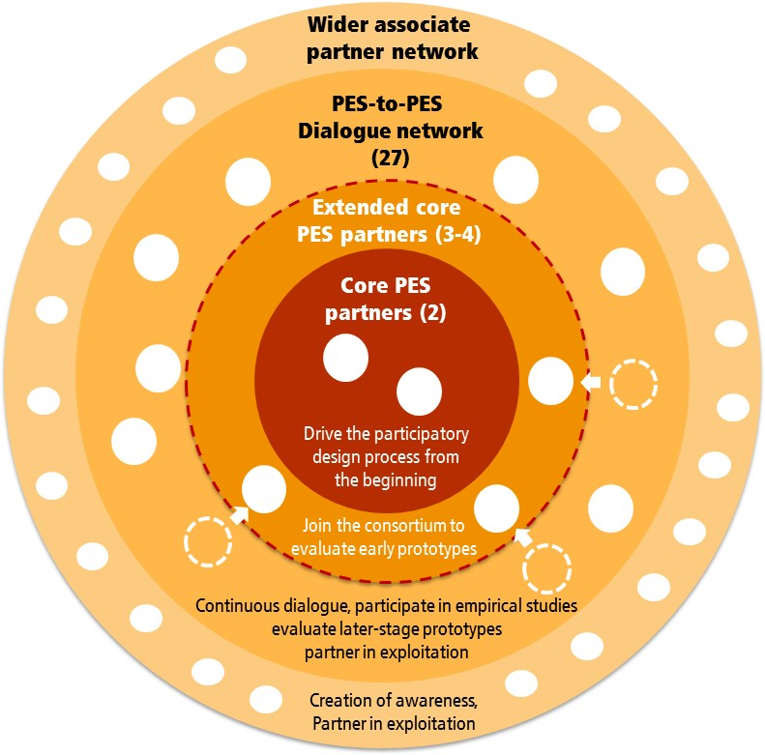
Figure 2: Associate Partner Network (change this diagram put an inner circle of RI, Agencies, the other SWAFS etc)

Communication with the APN is mainly via events and regular electronic consultation. All APN members receive the project newsletter on a regular basis. Additional benefits that the project offers to the members of the APN include:
- Participation in selected project activities
- Meetings at major events in Europe related to REINFORCE topics (possibility to reimburse travel costs)
- Mutual knowledge exchange
- Potential for further collaboration initiatives
- Name and logo on REINFORCE website
- Banner to include in own website (Member of REINFORCE Associate Partner Network)
A media package is provided to all new members of the APN including guidelines on how make reference to the project and supporting material.
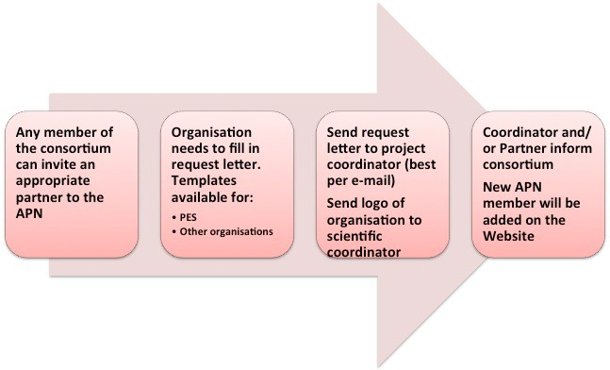
The mechanism for joining the APN is kept simple and can be managed by any consortium member:
Figure 3: Associate Partner Network Membership Process

External communication procedures
For external communication a series of promotional material has been prepared in a flexible manner, allowing partners to address external stakeholders with content specifically adapted to their interests. A flexible flyer will be used and adapted by any project partner, including translations into different languages. All partners are involved in dissemination activities to address their contacts and networks for the purpose of promoting the project and widening the user community of REINFORCE. WP9 is coordinating the external communication and dissemination activities and it is planned to have several types of contents and media objects to support it.
The consortium agreement specifies the procedures that should be applied when preparing or submitting a publication, e.g. journal or conference paper, which is based on the project results. In addition, the following sentence should be added to any publication or dissemination material:
"This project has received funding from the European Union’s Seventh Framework Programme for research, technological development and demonstration under grant agreement no. XXXX.”

Dissemination protocol for referring to RI partners
Formal approval by the RI organisation is needed for any information being made available publicly that involves any of the application partners; this has to be respected by all consortium partners. Time for reviewing the content and seeking official approval by the respective organisation needs to be built into the dissemination strategy to allow this to go through the process before going ‘public’. This applies to any content being published publicly such as website, flyers, newsletter, public presentation of aspects related to our RI application partners, etc.

Newsletter protocol
The following procedures have been defined for the preparation and publication of the REINFORCE newsletter:

      - The REINFORCE Newsletter will be issued at least twice a year and lead responsibility for this resides with the Dissemination Programme Leader (Trust-IT).
      - All content should have the approval of their authors and if necessary from the organizations they refer to in the content (e.g. when the newsletter includes content referring to a RI, authors should send the email with the approval/agreement from a responsible person on the organizations authorizing such content).
      - Partners can request a newsletter publication to highlight and support dissemination actions.
      - The Chief Editor for the Newsletter is XXX, who has responsibility for the final version of the Newsletter contents. In the event of any dispute, the Chief Editor will make a final decision on content working closely with the Work package leaders/Scrum team leaders and/or relevant RI organisations.
      - Any member of REINFORCE and/or its partners may submit an article or news item for inclusion in the REINFORCE Newsletter. Advance notice will be given on the maximum word length, photo and/or logo requirements. Reminders about upcoming newsletter publications will be sent, so partners can include their desired publication for review.
      - Set deadlines for receipt of an article(s)/news item(s) will be promoted to all REINFORCE consortium members in advance.
      - Any article(s) and/or news item(s) pertaining to a specific RI organisation(s) should be agreed and email consent given to the Chief Editor for inclusion in the REINFORCE Newsletter by the RI organisation(s).

Quality of deliverables and peer review
The peer-­‐review process for the REINFORCE project is set up in order to obtain and guarantee the quality of the deliverables (documentation, reports, software modules, prototypes, etc.) that will be produced during the course of the project and delivered to the European Commission, and more globally to the potential exploitations in the industry or service sectors. This section describes standards for the REINFORCE deliverables and presents the REINFORCE peer-­‐review procedure. A checklist for the deliverables and a template for peer-­‐review reports are given in Appendices to this document.

Project Deliverables
REINFORCE deliverables serve different purposes. Most of them are communication within the consortium and communication with other people outside the consortium. They are aimed at transferring the know-­‐how, to exploit the results and knowledge generated by the project. Deliverables should be written with their target readers in mind. They should be concise and easy to follow. The readability of a document is vital ingredient for its success. The following general structure should be followed and is as such provided in the deliverable template of the project:
    - Cover page
    - Amendment History
    - List of Authors/Contributors
    - Table of Contents
    - Abbreviations/Acronyms
    - Executive summary
    - Introductory part
    - Core part
    - References
    - Annexes (optional)
Annex I includes a checklist that should serve as a guideline when preparing a deliverable. An REINFORCE deliverable may be comprised of one or more volumes and may consist of the following parts:
    - The Main part is the part that summarises the results for high-­‐level executives, technical managers and experts with decision-­‐making competence. It is typically one document and may contain Appendices
    - Annexes are optional and have detailed technical information for experts and implementers. They are added to the main part at the end of the document
Project deliverables may be classified according to different confidentiality levels, such as public (PU) or restricted (RE). In the DoW the big majority of REINFORCE deliverables have been classified as PU and a few have been defined as RE regarding their dissemination level. While PU means completely public access, RE means that the deliverable may only be distributed to partners within the REINFORCE consortium and to a restricted group of persons specified by the consortium, including Commission Services. Marking most of the deliverables as PU follows the openness strategy of the project. In the case consortium members want to change the level of confidentiality of any of the deliverables this requires a decision by the General Assembly.

In the following the steps to be taken for publishing a deliverable are listed:
- These part form the basis for the deliverable
  - Title and description of the project deliverables
  - The name(s) of the deliverables editor(s)
  - The deliverable history including names(s) of contributors and internal reviewer(s) in charge of the peer review for the deliverable
- The people appointed to generate parts of the Deliverable – the authors – provide their contribution to the editor.
- The editor(s) prepare draft 0.1 of the Deliverable by assembling and integrating all contributions. This draft is discussed with all authors. It is recommended to involve the internal reviewers already at this stage.
- When the editors and the authors are satisfied with the results achieved, the editor issues draft 1.0 and puts it on the REINFORCE Google Drive and sends a note to the consortium.
- They inform the internal reviewers and ask for a quality check, opinions and constructive comments within a defined deadline (normally one week).
- The editor deals with all the comments and problems raised, if necessary with the help of the authors. This is a critical phase due to the many interactions involved. It may be necessary to have a meeting (physical, audio-­‐ or video conference) in order to speed up the process for reaching a consensus on the amendments.
- The editor prepares draft 2.0, puts it on the REINFORCE Google Drive and informs the project manager (Barbara Kieslinger) and the whole consortium that the deliverable has reached final status and can be submitted to the EC and the reviewers.
- The deliverable is sent to the PO and the EM reviewers only by the project manager.

Peer review process
One of the feasible means to enhance the quality of the project deliverables is an internal peer review system. REINFORCE deliverables shall be evaluated by 2-­‐3 reviewers so as to gather diversified and balanced viewpoints. For restricted REINFORCE deliverables, only reviewers from the participating institutions shall be invited to the peer review procedure. Public deliverables can also be reviewed by invited external experts, for example from an Advisory Board member.
Peer reviewers should be nominated by the editor(s) at least 3 weeks before the due date of the deliverable and communicated to the consortium. Nominated peer reviewers can turn down the invitation with clear justification (e.g. lack of expertise) and would thus be requested to nominate another candidate.
Consented peer reviewers are required to produce a peer review report within 7-­‐10 days after receiving the deliverable from the editor. In case of any expected delay, peer reviewers should have notified the editor and the project manager immediately. During the review process, peer reviewers are encouraged to discuss the problems identified in the deliverable with the main author/editor. Peer reviewers are advised to pay particular attention to the following points:
    - Is the deliverable aligned with the objectives of the project and relevant work packages?
    - Does the deliverable makes a significant contribution to the project or not?
    - Is the content of the deliverable focused on the intended purpose? Is the content of the deliverable presented in a precise and to-­‐the-­‐point manner?
    - Is the length of the deliverable justified? Are there superfluous or irrelevant parts that should be deleted? Are there overlong parts that should be shortened? Are there any parts that are written in flowery language and/or that are unspecific or redundant?
    - Are there many grammatical errors and/or typographical errors and/or incomprehensive sentences? Specifically, clear annotations indicating errors and suggested corrections are very helpful for the authors of the deliverable. The annotated deliverable may be sent back to the editor/authors via email together with the peer review report.
    - Does the deliverable require substantial revision or rewriting? If yes, it will facilitate the revision process if some concrete suggestions how to improve the deliverable are given.
Review results are described in a peer review report (see Annex II), which contains the following information:
    - Basic information about the deliverable, author and peer reviewer
    - Comments on the length and content of the deliverable
    - Major strengths and weaknesses of the deliverable
    - Review summary
If minor or substantial revisions are necessary, authors of the deliverable should make changes and produce the final version of the deliverable before due submission date. The final responsibility for the content of the deliverable remains with the editor and authors and it is thus their final decision about how to address and integrate the feedback from the peer reviewer. The review reports will be made available internally for the consortium only.

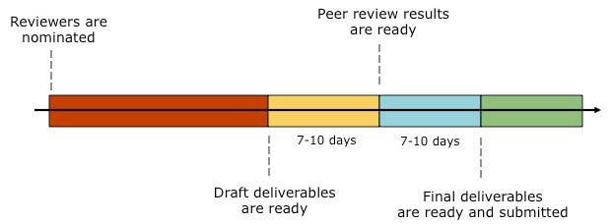
Fi

Figure 4: Peer Review Process

Regular internal surveys
Based on experiences from previous projects REINFORCE is committed to a continuous improvement process on the project management level. In addition to open and transparent communication and decision-­‐making, the project management uses anonymous surveys every three months. These surveys are kept brief to ensure broad participation by each project member. The survey consists of three sections
    - Project management. In this section, participants are asked to share their positive and negative observations about the project, both in terms of a four scale rating and open comments.
    - Current topics. The second section changes from survey to survey and focuses on topics that are currently important within the project. This can range from collaboration infrastructure, via satisfaction about results, to specific WP-­‐level topics.
    - Expectations and perceived risks. The third section focuses on the future and asks participants to share their perception about risks and expectations.
An essential element of this survey process is that the results are discussed and reflected upon as the first slot in project meetings. This allows for reacting to arising issues quickly and addressing them collaboratively, e.g., by adapting the agenda.

Risk management
As stated above, the regular internal surveys are checking perceived concerns and risks by all consortium partners. Thus risk management is closely connected to the regular survey method and the project management receives important input from the surveys. In addition, the quarterly reports that each partner submits online in the project Wiki also include a section on possible risks, deviations or corrective actions be reported to the project management.
The basic risk management methodology to be followed in the project and which is mainly being fed by the internal surveys as well as the quarterly reports and internal discussions, consists of four subsequent steps:
    - Risk identification – areas of potential risk are identified and classified.
    - Risk quantification – the probability of events is determined and the consequences associated with their occurrence are examined.
    - Risk response – methods are produced to reduce or control the risk, e.g. switch to alternative technologies.
    - Risk control and report – lessons learnt are documented.
Risks with medium or high probability and severe impact are handled with particular caution during the project. At this point, it is expected that the project safely achieves its expected results.
This is also supported by the preliminary risk analysis. Normal project risks are managed via “good-­‐practice” project management and rely on the experience from the successful research projects that the partners have been performing. The close supervision and tight control both by the project management and by the various Boards ensures that results are available in time and with adequate quality.
WP1 is responsible for close monitoring of the progress and risk identification. Risk identification is however also collaboratively encouraged as part of reflective sessions during the project meetings Early communication of risks is encouraged as well as discussions, in order to achieve a profound understanding of risks. The project management promotes an open communication culture to openly discuss any issues arising.

SWOT
Another instrument closely connected to the internal survey is the SWOT analysis, as the results of the surveys can also provide valuable input for the SWOT analysis, which is planned to be performed yearly.
The SWOT analysis is a structured planning method to evaluate the Strengths, Weaknesses Opportunities and Threats of a particular undertaking, be it for a policy or programme, a project or product or for an organization or individual. It is generally considered to be a simple and useful tool for analysing project objectives by identifying the internal and external factors that are favourable and unfavourable to achieving that objective. Strengths and weaknesses are regarded internal to the project while opportunities and threats generally relate to external factors.
Strengths can be seen as characteristics of the project that give it an advantage over others while weaknesses are regarded as characteristics that place the team at a disadvantage relative to others. Opportunities comprise elements that the project could exploit to its advantage whilst threats include elements in the environment that could cause trouble for the project.
Question to be answered during the SWOT analysis comprise: Strengths (S):
    - What do we do well? What are our assets?
    - What advantages does the project have? What do we do better than anyone else? What unique resources can we draw upon that others can't?
    - What are our core competencies? What is the Unique Selling Proposition (USP)?
    - What do other people see as our strengths? Weaknesses (W):
    - What could we improve? What can we do better?
    - What should we avoid?
    - Where do we lack resources?
    - What factors minimise the outcome?
    - What are external people likely to see as weaknesses? Opportunities (O):
    - What good opportunities can we spot? What are the emerging political and social opportunities?
    - What interesting trends are we aware of? What are the economic trends that benefit us?
    - What new needs of RI and other future users could we meet?

Threats (T):
    - What obstacles do we face?
    - Where are we vulnerable?
    - Could any of our weaknesses seriously threaten our results? What are the negative political and social trends?

To develop strategies that take into account the SWOT profile, a matrix can be constructed. The SWOT matrix (see below) includes strategies that make best use of strengths and opportunities and minimise weaknesses and threats. SO-­‐Strategies pursue opportunities that are a good fit to the strengths. WO-­‐Strategies overcome weaknesses to pursue opportunities. ST-­‐Strategies identify ways that the project can use its strengths to reduce its vulnerability to external threats. WT-­‐Strategies establish a defensive plan to prevent the weaknesses from making it highly susceptible to external threats.

SWOT Matrix | Strengths | Weaknesses
Opportunities | SO-­‐Strategies | WO-­‐Strategies
Threats | ST-­‐Strategies | WT-­‐Strategies
Figure 5: SWOT Matrix

After the first matrix has been drawn from the answers by the consortium, the following questions should be answered during the discussion and establishment of the project strategy:
    - How to make best use of strengths and opportunities?
    - How to best minimise weaknesses by making best use of opportunities?
    - How to make best use of strengths by reducing risk of threats?
    - How to best minimise weaknesses even with the expected threats?
While SWOT can be a good complementary tool for analysing the project and redefining strategy, it has also several blind spots. These comprise, for instance that SWOT is a linear analysis and an expert's or group’s monophonic analysis. In the case of the REINFORCE project some external view,
e.g. from the Advisory Board would give an important complementary interpretation of the project development. Overall, SWOT is an easy usable tool that provides quick access to the positive and negative aspects of a project and its environment and seems appropriate for the REINFORCE project to be performed on a yearly basis.

Glossary/Definition of core concepts
For a better common understanding of the core concepts of the project the consortium decided to prepare a glossary on the internal Wiki. It is understood as a living document and communication tool that supports the whole team in shaping a common understanding of the terms and concepts used in the project. During the first two years the glossary has grown continuously and includes currently the following terms:
    - RI
    - MOOC

Project templates
A series of templates have been prepared so far in order to streamline processes and achieve a unified approach to project documentation and communication amongst project partners. The following templates are currently available for the whole consortium and are accessible via the project Wiki and the shared Google Drive:

    - Deliverable template
    - Peer review template
    - Online reporting template for quarterly/6-­‐monthly and yearly reports
    - Informed consent
    - Confidentiality agreement
    - Data exchange form
    - Project presentation
    - Project flexible flyer
    - Project poster

Tools and collaboration infrastructure
TO BE DECIDED IN A SEPARATE MEETING. While the previous section was concerned with the processes of communication and collaboration there is also a technical side to this and a number of technical tools are used to provide the REINFORCE collaboration infrastructure. It consists of several pieces:
  - REINFORCE mailing list is used for project-­‐wide asynchronous communication. The address of the mailing list is: Reinforce@ego-gw.it
  - Scrum team mailing lists for the collaboration in smaller scrum teams separate mailing lists were created.
  - Google Drive is used for sharing files and for real-­‐time co-­‐creation of documents
  - MediaWiki is used for adding structure and linking the various activities in the project (e.g., used for meeting calendar and minutes, overview of a living project plan etc.) ?????
  - Skype, ZOOM, Wibe, … and telephone are used for smaller or bilateral meetings and time critical matters
  - REINFORCE Website is used for presenting our work to the public
Special technical support is provided by the project technical coordinator PTC for all project members in order to make best use of the collaboration infrastructure. In a special meeting a hands on session demonstrated to partners the use of these technologies. This training is especially helpful for newcomers to the team who are not familiar with the collaboration infrastructure. The choice for this collaboration structures has been made taking into consideration practical aspects as well as privacy issues and access restrictions by some project partners.

Responsible Research and Innovation (RRI)
The European Union is stressing their support for socially desirable science and technology and has implemented an ambitious aim with regards to Responsible Research and Innovation (RRI) in Horizon 2020, the current Framework Programme for Research and Innovation. Although REINFORCE is a project, still officially running under the previous Framework Programme (FP7), the aims defined under the heading of RRI include important values that we also want to apply in the context of this project.
Generally speaking RRI is doing science and innovation with society and for society, aligning outcomes with the values of society. It brings together different aspects of the relationship between science and innovation with society, including ethics, gender equality, open access, public engagement, and science education. According to the working definition provided by the project RRI-­‐Tools “Responsible Research and Innovation is a dynamic, iterative process by which all stakeholders involved in the R&I practice become mutually responsive and share responsibility regarding both the outcomes and process requirements”¹.
The two aspects most relevant for REINFORCE are ethical issues and open access. These are treated in more detail in the following sections of the document.
In terms of RRI processes Stilgoe et al. (2013) defines the following dimensions to be considered: “anticipation (envisioning the future and understanding how present dynamics of promising shape the future), reflexivity (which occurs as first-­‐, second-­‐ and third-­‐order learning), inclusion (the involvement of a wide range of stakeholders, such as users, in the early development of science and technology) and mutual responsiveness (responding to emerging knowledge, perspectives, views and norms). In addition, three process requirements were added: diversity, meaningful openness (instead of previously proposed transparency) and adaptive change”.
Here, the most important dimensions affecting the work of REINFORCE research are ‘meaningful openness’ and adaptive change. Meaningful openness has been replacing the claim to make research completely transparent, since insight into process structure, agenda-­‐setting and outcomes also needs to make sense in the context of the content and the process at hand. In the case of REINFORCE the RI context is very sensitive to sharing organizational insights with a wider audience. Thus relevant procedures that respect the privacy and security aspect of not only the individuals but also the organisational integrity have been defined, e.g. in the specific dissemination protocol. Still, the project is committed to offering open access to scientific results as far as possible following ethical principles.
Adaptive change describes how an RRI process must not only allow for learning on content and procedures, but must leave room for actors and organizations to adapt in accordance with such learning. This claim of RRI fits very well with the overall topic of REINFORCE, since learning processes related to professional identity transformation aim to support the adaptation process of individuals as well as organisations.
The user engagement and evaluation process conducted so far has very much been affected by adaptive changes due to the different contexts, into which the REINFORCE research is embedded.
The project RRI-­‐Tools (http://www.rri-­‐tools.eu/) is currently developing a toolkit to support projects in performing RRI. REINFORCE plans to trial out some of the tools available in the near future to evaluate our current research approach in respect to RRI principles.

1http://www.rri-­‐tools.eu/documents/10182/16038/RRI+Tools+Policy+Brief/fcadbf7f-­‐5b82-­‐401c-­‐8cfe-­‐
d478c45fec59

Ethical guidelines
Ethics is an integral part of research, from the conceptual phase to the publication of research results. The consortium of REINFORCE recognises its responsibility to ensure that the highest standards of integrity and professionalism are observed in the conduct of its research. It is clearly committed to respond effectively to potential ethical issues that will arise during the course of the project and has consequently defined a set of procedures for dealing with ethical issues in a responsible way.
The main tasks are the design of rigorous and robust ethical procedures that protect the identity and privacy of research participants, obtaining informed consent and communicating benefits and risks to the involved target groups.
The research investigations carried out as part of REINFORCE will include data collection from individuals and organisations remotely as well as in person. In order to achieve the goals defined within the research tasks of the work programme the consortium is required to collect personal data from potential future users, mainly employees from European RI organisations. Such data is likely to include data that relates to individual interaction with the tools from face to face and online interviews as well as automatically logged usage data, together with basic demographic data and questionnaire data. These data are essential for designing and validating the conceptual framework and tools as well as improving the developed technology and services.

Data protection and privacy
During the data collection phase, the data protection issues involved with handling of personal data will be addressed by the following strategies:
Volunteers to be enrolled will be comprehensively briefed, so that they are able to exercise informed consent regarding their participation. The purposes of the research, the procedures as well as the handling of their data (protection, storage) will be explained both in writing and verbally in the project information form. For all interviews these explanations will be part of the initial briefing of interviewees, and informed consent Annex VI (see below) shall be agreed and authorised by both the study participants as well as the respective research partner.
For the cases when data, e.g. usage data, will be collected by the learning tools automatically the participants will be informed about the purpose and procedures in written form in a data collection and privacy policy statement published in the tool, e.g. social platform. The participants will have to confirm that they agree with the policy and give explicit consent for their data to be collected, processed, stored and used in line with the policy statement before the registration to the system. Only relevant and necessary data will be collected. The participants will have a right to receive a copy of the data that have been collected about them and they will also have a right to have his or her data deleted before the end of the project.
The data exploitation will be in line with the respective national data protection acts. Since data privacy is under threat when data are traced back to individuals – they may become identifiable and the data may be abused – so all data will be anonymised. This will apply to logging from the system, questionnaires, interviews, observational studies at the workplace, focus groups and other methods this research for data collection. Storage will be exclusively in anonymised forms so the identities of the participants can only be known by the research partners involved. Raw data collected from interview protocols and audio files, will be shared within the consortium partners only after having signed a confidentially agreement. For the exchange of highly sensible data a special data-­‐exchange form (Annex V) will be used additionally between relevant partners. Raw

data that may reveal the identity of individual study participants (RI employees) will not be shared with the organisations participating in the studies (RI employers). Reports based on the interviews, focus group and other data gathering methods will be based on aggregated information and comprise anonymous quotations respectively.
Given the sensitive data requested in some of the user studies, all project partners involved in data analysis and/ or sharing personal data, sign a confidentiality agreement (Annex IV). These privacy guidelines ensure that personal data is treated with the utmost care to ensure privacy of individuals.
Data will be stored on password-­‐protected servers at the partner institution responsible for data collection and analysis. Persons who have access to this data are defined in the Data Exchange Form (Annex V). The data will be used only within the project framework of REINFORCE and will not be made accessible for any third party. It will not be stored after the end of the project (incl. the time for final publications) unless required by specific national legislation.
The stored data do not contain the names or addresses of participants and where used in publications (e.g. reports, articles) full anonymity will be verified by participants before use (i.e. RI participants will be invited to read the outputs, to ensure that there is no way of identifying individuals).

Communication strategy
Study participants will be made thoroughly aware of the potential benefits and possible risks of participating in the project. Specific documents, such as the Project Information Sheet (Annex
VIII) or the informed consent forms (Annex VI and Annex VII) describe the engagement strategy on an organisational and individual level.
The main means of communicating benefits and risks to the individual is the informed consent form. Prior to consent, each individual participant in any of the studies in REINFORCE will be clearly informed of its goals, its possible adverse events, and the possibility to refuse to enter or to retract at any time with no consequences. As indicated above, this will be done through the project information form and this will be reinforced verbally.
In order to make sure that participants are able to recall what they agree upon when signing the informed consent the forms will be provided in the native language of the participants. In addition, the consortium partners will make sure that the informed consent is written in a language suitable for the target group(s).

Informed consent
As stated above informed consent will be collected from all participants involved in REINFORCE studies. An English version of the declaration of consent form is provided in Annex VI. An English version of an example of a data collection and privacy policy statement for data logging in a community of practice is also given in Annex VII. The participants will be able to withdraw their consent at any time.

Relevant regulations and scientific standards
The consortium is following European regulations and scientific standards to perform ethical research. The following lists some of the basic regulations and guidelines.
The REINFORCE project will fully respect the citizens’ rights as reported by EGE and as proclaimed in the Charter of Fundamental Rights of the European Union (2000/C 364/01), having as its main goal to enhance and to foster the participation of European citizens to education, regardless of cultural, linguistic or social backgrounds. Regarding the personal data collected during the

research the project will make every effort to heed the rules for the protection of personal data as described in Directive 95/46/EC².
In addition, the consortium is following the following European Regulations and Guidelines:
    - The Charter of Fundamental Rights of the European Union: http://www.europarl.europa.eu/charter/default_en.htm
    - EU Guidelines on ethics: http://cordis.europa.eu/fp7/ethics_en.html
    - EU Code of Ethics: http://www.respectproject.org/ethics/412ethics.pdf
    - European data protection legislation: http://ec.europa.eu/justice/data-­‐ protection/index_en.htm
    - RESPECT Code of Practice for Socio-­‐Economic Research: http://www.respectproject.org/code/index.php?id=de
    - Code of Ethics of the International Sociological Association (ISA): https://www.zsi.at/attach/isa_code_of_ethics.pdf
    - Guidelines and recommendations of Coaching as a Profession: http://www.dbvc.de/fileadmin/user_upload/dokumente/Coaching-­‐ Kompendium/DBVC-­‐Kompendium_englisch.pdf
    - Code of Ethics of the International Coach Federation: http://www.coachfederation.org/about/ethics.aspx?ItemNumber=854&navItemNumb er=634

National and Local Regulations and Standards
In addition to the more general and EU-­‐wide guidelines, project partners have to adhere to, and respect, national regulations and laws as well as to research organisational ethical approval as requested by the own institutions. All partners are aware of their responsibilities in that respect and will follow the respective guidelines.

Privacy aspects as part of REINFORCE research
Apart from the ethics involved in the data gathering and analysis, project REINFORCE is approaching privacy and data protection issues additionally from an investigators perspective as one of the objectives is to develop a concept for privacy for RI staff, organisations and clients in the context of new technologies. Privacy-­‐awareness in facilitation is a core challenge to achieve in the project.
Especially two partners, RUB and JSI, have extensive expertise in this field and are leading the research work dedicated to this challenge. Together with other research partners they look into the technical, organisational and legal side of implementing privacy-­‐sensitive technology-­‐ enhanced facilitation at the workplace and define a privacy-­‐aware socio-­‐technical engineering methodology that forms part of the overall concept of facilitation and the technical implementation. The privacy concept is developed in WP3. Technical privacy protection mechanisms will be deployed in the tools, such as address masquerading, data encryption, and data anonymization.

2 http://eur-­‐lex.europa.eu/legal-­‐content/EN/TXT/?uri=URISERV%3Al14012

Open source and open access strategy
The project firmly believes in openness to be a major factor for innovation. There are many examples of how open innovation is a successful model, especially in domains where many different stakeholders are required to bring about effective change. Openness has many facets. The most important ones are:
  - Open project collaboration. The Associate Partner Network as an instrument to collaborate with external partners, both RI organizations and other institutions, has been an integral part of REINFORCE from the beginning and builds upon experiences in other projects. All partners are committed to developing (working) relationships with external partners for mutual benefit.
  - Open source technology. From a technology perspective, the project builds upon open source technologies and wants to share its results with the community. Business models and exploitation strategies are not based on locking down access to project results, but on providing added value through services. This also supports the open project collaboration with external partners.
  - Open access to scientific results. From a scientific perspective, the consortium clearly favours open access to its scientific output, which is supported by several project members’ internal policies of supporting open access in general.
The open source strategy and the open access strategy will be detailed in the following sections.

Open source strategy
An open source strategy has its clear advantages in lowering the barriers of reusing REINFORCE results in various contexts, and allows REINFORCE to build upon the assets developed by an open source community.
After the release as open source software, there is no further need for negotiation on licenses or similar. Furthermore, it allows for external individuals and organisations to join the further developments under fair and clear terms. This can strengthen the impact of the project, particularly for those parts, which need further research and implementation experience to evolve into a clear product offering.
Open source strategies do not limit the individual partners in exploitation their own achievements in the project if needed. They can still license under different conditions to their customers, e.g., without the need for making further developments open source (as GPL enforces), too.
This open source strategy applies to both source code, and the content that will become part of the REINFORCE MOOC offering, where CreativeCommons licenses will be considered.
As part of the exploitation activities, key questions will be investigated that are associated with open (source) licensing:
    - How to deal with pre-­‐existing products? While it is straightforward to agree on a common licensing strategy for the newly developed parts, there are many constraints associated with pre-­‐existing software that might be partially bound to other IPR regimes. This will be also considered as part of the selection process for technologies to reuse.

    - Which license to choose? Open source projects can choose from a variety of licenses. On the one end, there are very liberal licenses with almost no constraints like the Apache Software License where the software and its source code can be used and developed further for almost any purpose. On the other end, there are “viral licenses” which require any user of the software to open their source code as well, e.g., in case of changes of the components (LGPL) or even if our components form part of an application (GPL). The latter clearly fosters the open source community, while commercial organisations might be intimidated as some – especially bigger companies – have strict policies on not using
(L) GPL. Dual-­‐licensing can be a way out, but will only work as long as IPR are clearly identifiable, which will become difficult in a collaborative open source community. The choice of a license is further constrained by the libraries and components that were used by the project’s developers. This similarly applies to content, where the Creative Commons regime is a useful framework.
    - How to create a living community? One of the major benefits is that open source can leverage community development resources for further development. But this depends on a living community. To achieve such a living community with a sufficient visibility and a critical mass of interest in the field of technology enhanced learning.

Open access
In line with the EC policy initiative on open access³, which refers to the practice of granting free Internet access to research articles, the project is committed to follow a publication strategy considering a mix of both 'Green open access' (immediate or delayed open access that is provided through self-­‐archiving) and 'Gold open access' (immediate open access that is provided by a publisher) as far as possible.
All deliverables labelled as “public” will be made accessible via the REINFORCE website. The publications stemming from the project work will also be made available on the website as far as it does not infringe the publishers rights.

Conclusion
This handbook describes the main procedures of the REINFORCE project to operate successfully and effectively in order to achieve high quality project results following a responsible research and innovation (RRI) approach. Open access, ethics, and engagement of all societal actors are amongst the key elements of the European RRI framework (European Union, 2012). REINFORCE is clearly committed to respond to societal challenges in a responsible way by the research topic itself as well as by the way the research is conducted.
While this handbook is provided in the form of a report and deliverable it is a living document in the sense of being continuously updated and challenged by the consortium. The processes described in here are implemented in the daily work of the consortium and most of the elements are separately available on the collaboration infrastructure such as the project Wiki and shared Google Drive.
This updated version of the handbook includes all updates made during the first two years, especially considering the specific aspects related to RRI that have emerged through the interaction with the application partners. The handbook includes the most relevant elements of the project structure related to high quality responsible research. In case of additional requirements coming up during the coming period updates will be made accordingly

3http://ec.europa.eu/research/science-­‐society/index.cfm?fuseaction=public.topic&id=1294&lang=1

References
European Union, (2012): Responsible Research and Innovation: Europe’s ability to societal challenges. http://ec.europa.eu/research/science-­‐society/document_library/pdf_06/responsible-­‐ research-­‐and-­‐innovation-­‐leaflet_en.pdf
Stilgoe, J., R. Owen, P. Macnaghten (2013) ‘Developing a framework for responsible Innovation’ in Research Policy, Vol. 42, Issue 9, P. 1568–1580

Annex I: Checklist for deliverables
- Overall technical evaluation of the deliverable
  - Does the deliverable contain new, or value added information?
  - Are there any major technical errors, omissions, lack of necessary details?
  - How do the results compare with the state of the art and/or parallel activities?
  - What value does the document add to the project partners?
- Executive summary
  - Are the following questions clearly asked and answered:
    - Which problem(s) and key questions of interest to intended readers are addressed?
    - What are the expected main benefits of this deliverable?
    - What are the results contained in this deliverable?
    - Who are the main consumers for this deliverable, e.g. who should read it?
    - Why should I read the deliverable?
    - Suggestions/recommendations for follow-­‐up actions by project participants and/or by general public.
  - Is the length acceptable (2 pages, maximum)?
  - Introduction
    - Is the purpose of the document clearly stated?
    - Is the technical subject properly introduced?
    - If necessary, is there a guide to the reader (document structure, short description of chapters and relationships)?
    - If necessary, are there statements on technical assumption, readers’ prerequisites, relationships with other documents or parallel activities?
  - Main part of the deliverable
    - Does it contain what was defined in the deliverable description in the DoW?
    - If something has been left out, have clear and valid reasons been given as to why?
    - Is the key part structured in a logical way?
    - Is the content appropriate for the intended audience? Does it only include essential information?
    - Does it duplicate or contradict standards or other on-­‐going known initiatives? If yes, the affected standard or initiatives need to be identified.
    - Is the length acceptable (approx. 30 pages maximum for main part)?
  - Conclusion
    - Are conclusions reached? Are they within the consortium perspective?
    - Are any necessary follow-­‐up actions clearly indicated?

    - Are the conclusions consistent with the executive summary?
    - Should this Deliverable be
      - Utilised by other projects?
      - Released (in full or part) to the Associated Partner Network or to RI initiatives such as RI-­‐to-­‐RI dialogue?
  - Annexes (optional)
    - Are they complete in all parts?
    - Relevant for the content described in the deliverable?

Annex II: Peer review template
Instructions:
 Peer reviewers should fill out all six sections in this template.
 For sections 2, 3, 4 and 5 please insert as much text as necessary.
 Please send the completed template to the editor/main author on or before the specified due date.

- Basic Information

Deliverable Nr &Title:
Main Author/Editor:
Peer Reviewer (Institution, Person):
Date of Receipt of Deliverable:
Date of Sending out the completed peer review:

- Length of the deliverable

  - Is the length of the deliverable justified? – YES -­‐ NO
  - If no, please specify by e.g. indicating parts that are superfluous, irrelevant, redundant, unspecific or would need more explanation?

- Content

  - Does the deliverable meet the objectives of the deliverable described in the respective Work Package Work Description? – YES -­‐ NO
If not, please indicate the parts where improvement is necessary.

  - Is the content of the deliverable focused and presented in a precise and to-­‐the-­‐point manner? – YES -­‐ NO
If not, please indicate the parts where improvement is necessary.

  - Does the deliverable require substantial revision or rewriting? – YES -­‐ NO If yes, please give concrete suggestions how to improve the deliverable.

- Major strengths
- Major weaknesses

- Review Summary

The current version of the deliverable is [ ]:
1: applicable and ready to be submitted to the EC, if required; 2: applicable, but requires minor revisions;
3: inapplicable and requires substantial revisions.

Is it necessary for the revised deliverables to be reviewed again before submitting it to the EC (1:Yes, 2: No)? [ ]

Other remarks:

Annex III: Project management survey

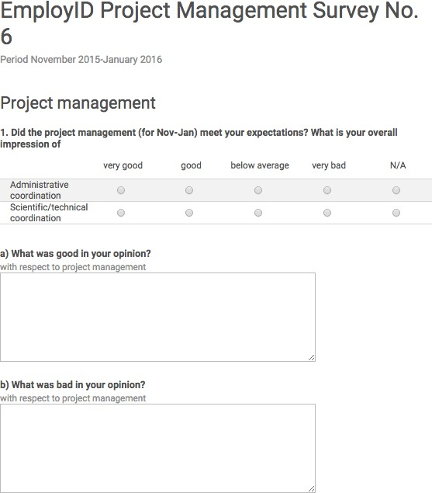

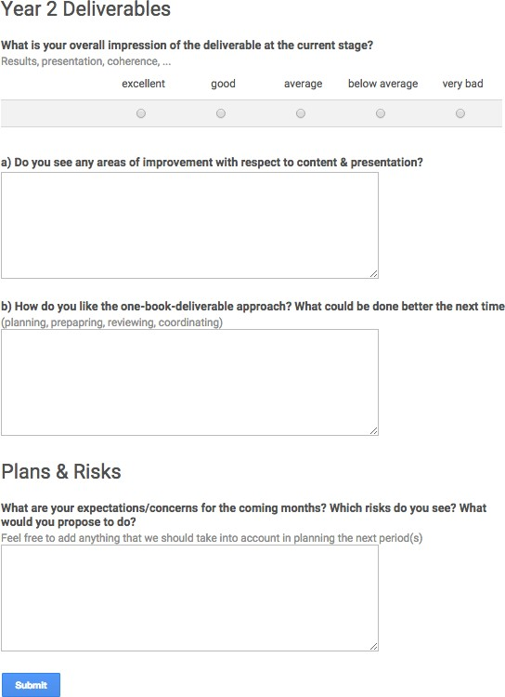

41

Annex IV: Confidentiality agreement
Confidentiality Agreement

The user study data shared between the researchers in the REINFORCE project contains personal identifiable information (PII) the usage of which is protected by law. To comply with this law, usage and sharing of data is restricted and it is essential that you follow the rules and guidelines described in the ethical guidelines defined for REINFORCE for collecting, processing, sharing and storage of data.
In addition to this you are obliged to comply with the following terms:
  - I will not share the participant data, collected by the project team, in which I am in receipt with any third parties, including the testbeds, employers of the participants, or other members of the consortium of the REINFORCE project without explicit, written consent from the person(s) who provided the data.
  - Where relevant, I will instruct the people for whom I have responsibility who have access to the data of the relevant ethical protocols and ensure that they follow the guidelines defined for the project, as listed below.
  - I will delete the data at least months after the project outcomes have been
published (recommended time is 3 months).

Declaration: I hereby declare my consent with the rules outlined above:

Date:.............................................................................................
Name & Organisation: .............................................................................................
Signature: .............................................................................................

List of persons in my organisation who have access to the data:

Annex V: Data exchange form

Data Exchange Form

As research partners in the REINFORCE consortium we agree to share personal identifiable information (PII) of individuals and/or organisations as defined in the Confidentiality Agreement.
This data exchange form documents the exchange between partners regarding sensitive data.

Researcher(s) responsible for the data (who collected the data originally)
Type of data (e.g. interview recording, questionnaires, etc.)
Sensitivity of data (describe briefly why this specific data is highly sensible)
Consent form signed by all involved participants
Storage location
Person(s) who have access to the data
Purpose of sharing
Confidentiality agreement signed
Data retention (timeframe for storing the shared data)

Date:.............................................................................................
Name & Organisation: .............................................................................................
Signature: .............................................................................................

Annex VI: Informed consent form for research participant
Declaration of Consent

The data collection from human participants is part of research activities within the larger context of an EU-­‐funded project named REINFORCE -­‐ Scalable & cost-­‐effective facilitation of professional identity transformation in public employment services (RI).

You have been invited to participate in the REINFORCE project and will have received information about the project separately.
Your data will be held and used on an anonymous basis only for the purpose of this project, REINFORCE. It will not be stored after the end of the project unless required by specific national legislation. Your raw data will be kept confident and will not be disclosed to any third parties. Written reports referring to your data will not contain any data that could lead to the identification of a specific data subject.
Your participation is voluntary, consent can be refused, and withdrawal is an option at any time.
Declaration of consent: I hereby consent for my data to be conveyed and documented for the above stated purpose. I confirm that I have been informed of the nature of REINFORCE and that my participation is voluntary. I am aware that I may withdraw my consent at any time.
Date:.............................................................................................
Name:..........................................................................................
Signature: ..................................................................................
Signature REINFORCE representative: ..................................................................................
For further information about the research project REINFORCE, please contact at any time:

____________________________________________
Please provide your contact data if we are allowed to contact you again with regard to your data (This information will of course be stored separately from your data!):

____________________________________________

Annex VII: Informed consent form for community of practice

Data collection and privacy statement

Introduction
This Data collection and privacy statement sets out the policy relating to the collection, storage, processing, use and disclosure of data that is being collected within a Community of Practice (CoP) platform.
The platform aims at encouraging and strengthening horizontal and vertical communication between the employees of the RI for the exchange of formal and informal knowledge, ideas, experiences, practices, skills and motivation. The platform has been set up and is being maintained as part of the REINFORCE project (http://REINFORCE.eu) from the 7th Framework Programme of EU, where RI is one of the partners (http://REINFORCE.eu/consortium-­‐ members).
Purpose
The purpose of data collection and processing is to help the partners of the REINFORCE project to evaluate:
- how is community learning taking place in work-­‐based social learning platforms and how can it contribute to the professional development of RI practitioners;
- how do RI practitioners facilitate the learning of others linking individual, community and organizational learning (social learning) and which roles can be identified.
Data
Only relevant and necessary data will be collected, processed or stored. The collected data falls into two categories: (1) automatically logged activity data of the platform users, and (2) the data and content provided by the platform users.
The first category includes data on time of access to the platform, read documents in the platform, interactions with other users, topic subscriptions, group membership, group management, and profile updates.
The second category includes answers to surveys, forum posts, comments to other posts in the platform, post tags, and indication of the useful posts.
No sensitive personal data on racial or ethnic origin, religious or similar beliefs, disability and other health matters, sexual life, political opinions or membership of trade unions will be collected within the CoP.
Data protection and storage
The RI and other REINFORCE partners will take appropriate technical and organisational measures to prevent unauthorised or unlawful processing and disclosure of personal data.
The collected data is stored on protected server at the RI. Selected staff at the RI and from the REINFORCE project partners has access to the raw data to facilitate the exporting of data, running assessment, or managing the dataset.
User provided content may also be visible to other CoP users if posted in public group forums.

Data processing
Before processing the collected raw data will be anonymized. The processed data will not include identifying information about the users.
The data will only be used within the framework of the REINFORCE project and will not be shared with the employer or any other third party. It will be made accessible to the consortium partners only after having signed the confidentiality agreement.
Written reports based on the surveys and other data gathering methods will be based on aggregated information and comprise anonymous quotations respectively.
Data retention
The raw data will not be stored after the end of the project (31. 1. 2018) unless required by specific national legislation. Anonymized data might still be used after the project finishes for the purpose of analysis.
Data access
The user has a right to receive a copy of the data that have been collected about him or her. The user also has a right to have his or her data deleted before the end of the project. Both can be requested in written form at the following address _.
Document version Version 1.0;

-­‐-­‐-­‐-­‐-­‐-­‐-­‐-­‐-­‐-­‐-­‐-­‐-­‐-­‐-­‐-­‐-­‐-­‐-­‐-­‐-­‐-­‐-­‐-­‐-­‐-­‐-­‐-­‐-­‐-­‐-­‐-­‐-­‐-­‐-­‐-­‐-­‐-­‐-­‐-­‐-­‐-­‐-­‐-­‐-­‐-­‐-­‐-­‐
Declaration of consent
I hereby consent for my data to be collected, processed, stored and used for the above stated purpose. I confirm that my participation is voluntary. I am aware that I may withdraw my consent at any time.

Annex VIII: Project Information Sheet

Put here our project information sheet

The potential importance of new & advanced technologies (including e‐coaching) and how they can be further exploited to: enhance professional practice; support service ethos; and improve delivery in Public Employment Services (RI) are central themes throughout this project. In an era of high unemployment, Public Employment Services have already responded to the changing demands of local, regional and national labour markets. The outcomes from this project will be designed to complement existing tools, accommodate existing working practices, avoid any additional workload and improve the efficiency of established practices.
http://REINFORCE.eu

BENEFITS
The project and participants will:
- Benefit from an overview of the EU challenges in labour markets that innovative learning, supporting services and use of technologies can tackle and support.
- Focus on solutions that potential users in DWP and other RI organisations identify as needed that build upon already existing practices. .
- Acknowledge existing levels of practitioner knowledge, skills and professionalism.
- Explore ways of developing good and interesting practices within DWP and other RI organisations through the use of networked learning facilitation tools to support, enhance and identify new solutions.
- Explore ways of improving performance in DWP and other RI organisations to meet better the needs of employers.
- Support and facilitate the professional identity development of practitioners and managers in DWP and other RI organisations through the efficient use of technologies, using a range of interventions (including advanced coaching, reflection, networking and learning support services).
- Support practitioners and managers in the prevention of work overload precipitated by rapidly changing pressures and demands from the labour market.
- Build upon career adaptability in practice and quality and evidence‐based frameworks, for organisational learning of RI staff.

CONTACT
Jenny Bimrose
Institute for Employment Research, University of Warwick jenny.bimrose@warwick.ac.uk

This project has received funding from the European Union’s Seventh Framework Programme for research, technological development and demonstration under grant agreement no. 619619

47

