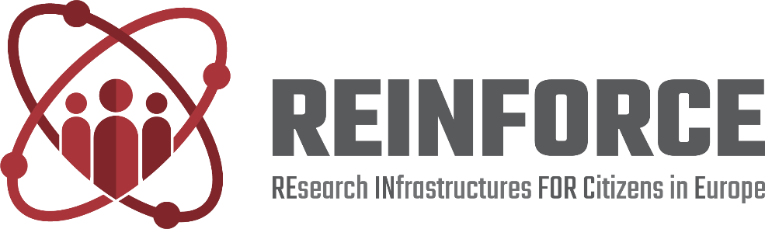

Project Title | REsearch INfrastructures FOR Citizens in Europe
Project Acronym | REINFORCE
Grant Agreement No. | 872859
Start Date of Project | 01.12.2019
Duration of Project | 36 Months
Project Website | www.reinforceeu.eu
D10.2 Dissemination materials

Work Package | D10.2 Dissemination materials
Lead Author (Org)
Contributing Author(s) (Org)
Due Date | DD.MM.YYY
Date | DD.MM.YYY
Version | V1.0

Dissemination Level
X | PU: Public
 | PP: Restricted to other programme participants (including the Commission)
 | RE: Restricted to a group specified by the consortium (including the Commission)
 | CO: Confidential, only for members of the consortium (including the Commission)

Versioning and contribution history
Version | Date | Author | Notes
0.1 | 28.01.2020 | Valeria Andreolli | Table of Contents (ToC)
0.2 | 04.02.2020 |  | Additional ToC sections
0.3 | DD.MM.YYY |  | Contents for Deliverable Abstract, section 1 and 2.1, 2.2
0.4 | DD.MM.YYY |  | Contents for section 2.2, 2.3, 2.3.1, 2.3.2 and 2.3.3
0.5 | DD.MM.YYY |  | Contents for section 2.4, 2.5 and 2.6
0.6 | DD.MM.YYY |  | Contents for section 2.7, 2.8 and 2.9
0.7 | DD.MM.YYY |  | Contents for section 3
1.0 | DD.MM.YYY |  | Contents for section 4

Deliverable Abstract
The dissemination of REINFORCE’ outputs has two major objectives:
- making the knowledge developed throughout the project available to the widest audience (public disclosure of project results),
- enhancing its exploitation potential (more stakeholders involved in the process).
Communication activities ensures that diverse actors and stakeholders are continuously engaged in a two-way dialogue with the project at a local, national and EU level with the aim of raising awareness of citizen science and design among a broad segment of the public who currently does not identify them as a source of value.

Disclaimer
This document contains information which is proprietary to the REINFORCE Consortium. Neither this document nor the information contained herein shall be used, duplicated or communicated by any means to a third party, in whole or parts, except with the prior consent of the REINFORCE Consortium.
Table of Contents

1. Introduction 6
2. Dissemination Material 7
2.1 Branding and logo 7
2.2 Landing page and website 8
2.3 Social media 11
2.3.1 Twitter 13
2.3.2 LinkedIn 15
2.3.3 Facebook 15
2.4 Poster 16
2.5 Roll- up banner 17
2.6 Flyer and Brochure 19
2.7 Press Release 20
2.8 Newsletter 21
2.9 Videos 21
3. Dissemination events 22
4. Conclusions 24

List of Figures
FIGURE 1 – LOGO 7
FIGURE 2 – DELIVERABLE TEMPLATE 8
FIGURE 3 – PPT TEMPLATE 8
FIGURE 4 – LANDING PAGE 10
FIGURE 5 – REINFORCE TWITTER ACCOUNT 11
FIGURE 6 – REINFORCE LINKEDIN ACCOUNT 12
FIGURE 7 – REINFORCE FACEBOOK ACCOUNT 12
FIGURE 8 – EXAMPLE OF LINKEDIN POST 15
FIGURE 9 – EXAMPLE OF FACEBOOK POST 16
FIGURE 10 – POSTER 17
FIGURE 11 – ROLL-UP BANNER 18
FIGURE 12 – FLYER COVER AND BACK COVER 19
FIGURE 13 – BROCHURE 20
FIGURE 14 – PRESS RELEASE 20
FIGURE 15 – NEWSLETTER TEMPLATE 21

List of Tables
TABLE 1 – EXAMPLES OF TWEETS 13
TABLE 2 – VIDEOS 22
TABLE 3 – LIST OF EVENTS 22

TERMINOLOGY
Terminology/Acronym | Description
CNRS | Centre National De La Recherche Scientifique
CSA | Coordination and Support Action
DoA | Description of Action
EA | Ellinogermanik i Agogi Scholi Panagea
EC | European Commission
EGO | European Gravitational Observatory
EU | European Union
GA | Grant Agreement to the project
IASA | Institute of Accelerating Systems and Applications
KPI | Key Performance Indicator
LC | The Lisbon Council For Economic
OU | The Open University
REA | Research Executive Agency
REINFORCE | REsearch Infrastructure FOR Citizens in Europe
UOXF | University of Oxford
WP | Work Package
ZSI | Zentrum Fur Soziale Innovation

Introduction
Dissemination and promotional activities are fundamental actions for a new project like REINFORCE, expected to be carried out through a broad spectrum of initiatives with a view to keep the entire community made of Stakeholders, Scientific Researchers and citizens abreast of the current project results and developments. The strategy includes both online and offline tools to maximise the reach of the project both on Digital and mainstream channels.
This Deliverable is completely aligned with D10.1 “Plan for the Communication and Dissemination of Results”, a comprehensive plan outlining the REINFORCE’s dissemination and communication strategy, planning activities and measurements criteria to be released in M4.
This document enumerates and describes exhaustively the list of the Branding and Visual Identity items, printed material (flyers, posters, brochures, Roll-Up Banners), video interviews, and Social Media channels which ensure a valuable source of information on the principal characteristic of the project and its demonstrators.

Dissemination Material

Branding and logo
The first way to “communicate” the project is the identification of the project logo. In REINFORCE, the logo is represented by a graphic item, the title of the project and the meaning of the acronym.
A consistent visual identity will be used for all communication and dissemination activities. Templates for external communication and documents will be also provided (see Figures 2 and 3)
As a result of this homogeneous and solid Branding strategy, the project aims at achieving the following outcomes:
- More effective memorisation and visual identification
- Guarantee a seamless presence across various online and offline formats
- Improved recognition across a Citizens Science-oriented audience
- Strengthened loyalty and trust from the audience
- Sustain the overall message that REINFORCE wants to convey
Information of EU funding will always be present by a prominently displayed EU emblem and the text suggested in the Grant Agreement: “The REINFORCE project has received funding from the European Union’s Horizon 2020 project call H2020-SwafS-2018-2020 funded project Grant Agreement no. 872859”. Furthermore, it will be disclaimed, that the content does not represent the opinion of the European Commission and the European Commission is not responsible for any use that might be made of such content.
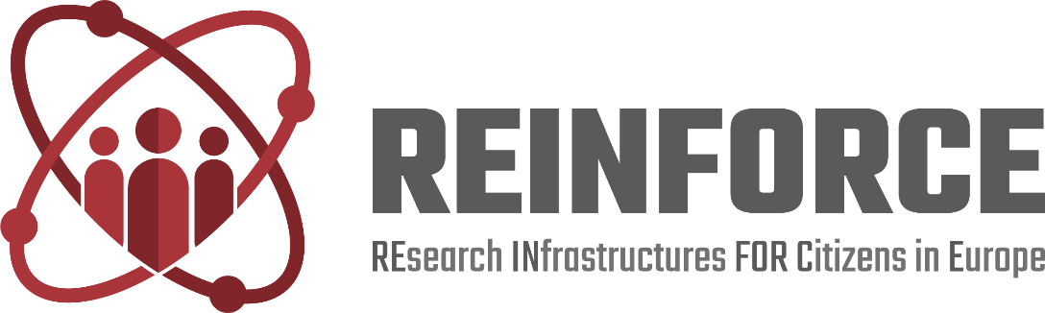
FIGURE 1 – LOGO
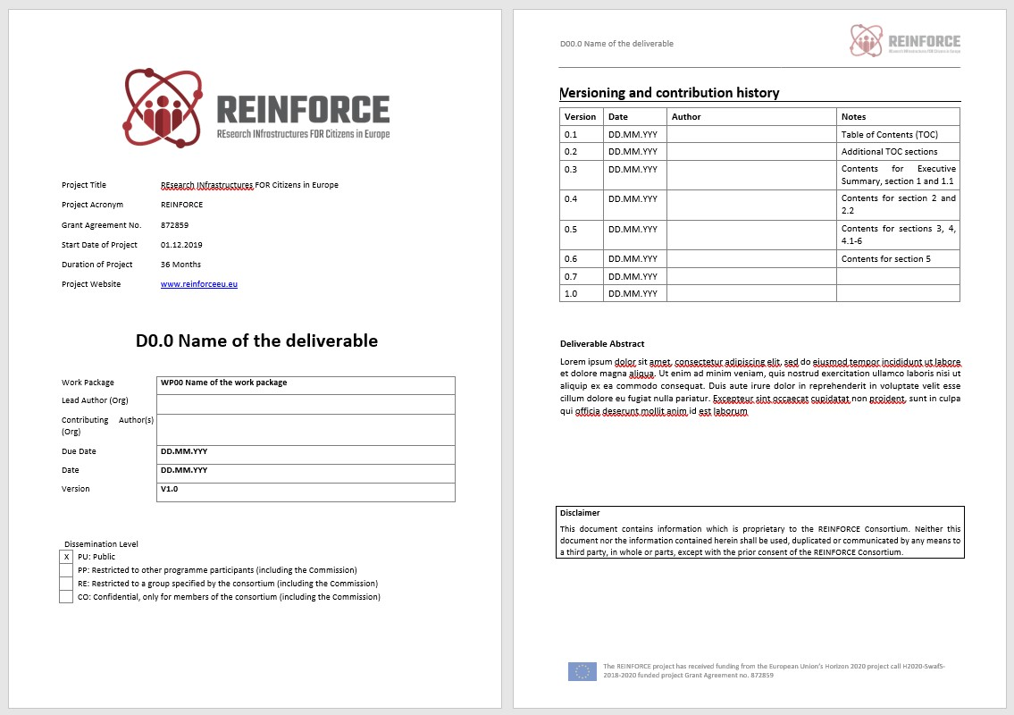
FIGURE 2 – DELIVERABLE TEMPLATE
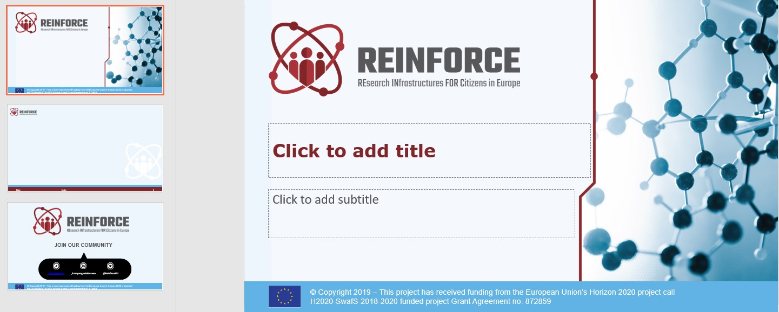
FIGURE 3 – PPT TEMPLATE

Landing page and website
As of December 2019 (M1), REINFORCE project has its own landing page, available at the following address: www.reinforceeu.eu
The landing page includes six sections, listing the goals, the demonstrators, the impacts, the partners, a contact form and a news section which is updated weekly.
Before the official release of a fully-fledged website, the Landing Page will allow to:
- Showcase with clarity the most important attributes of the project
- Speak to a broad audience and make a preliminary segmentation
- Start a Database by collecting profiled information on users who joined the platform
- Keep the community informed on the main developments of the project in its first phase

The full roll-out of the Website is expected to be completed by M6 of the project.
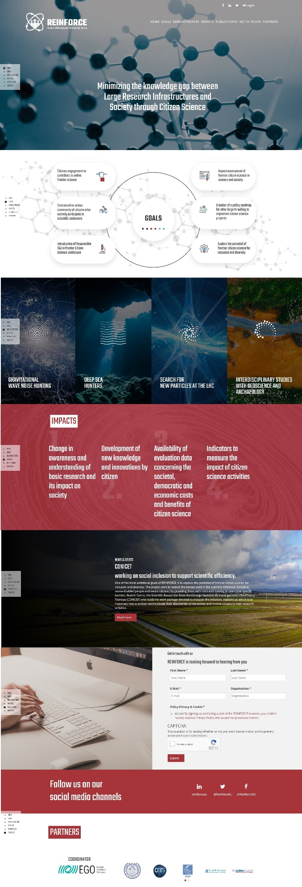
FIGURE 4 – LANDING PAGE

Social media
Three Social Media channels (Twitter, LinkedIn and Facebook) have been set up in M1 as a key-ingredient for the REINFORCE Digital strategy, with full alignment with the abovementioned visual and branding Identity.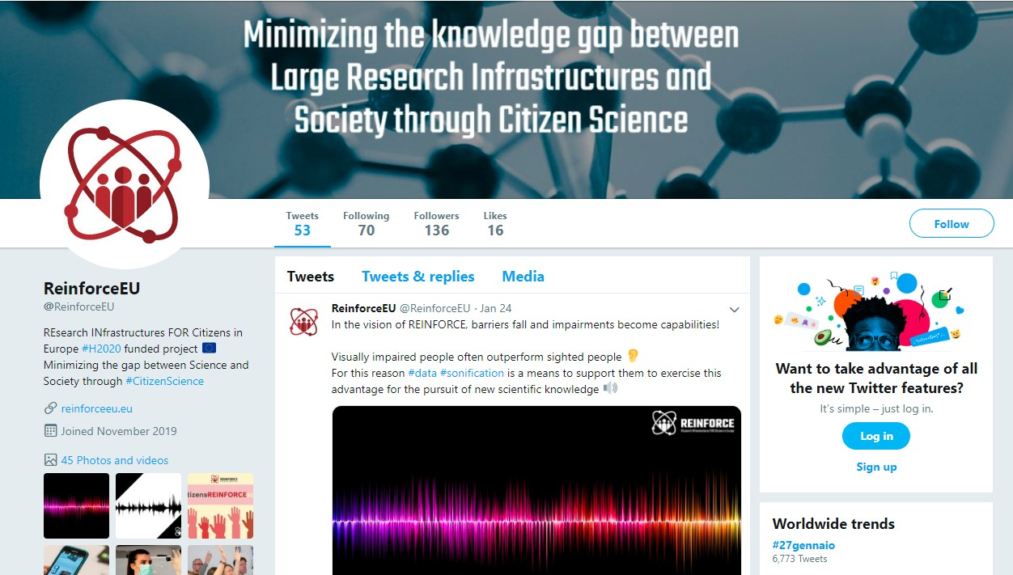
FIGURE 5 – REINFORCE TWITTER ACCOUNT

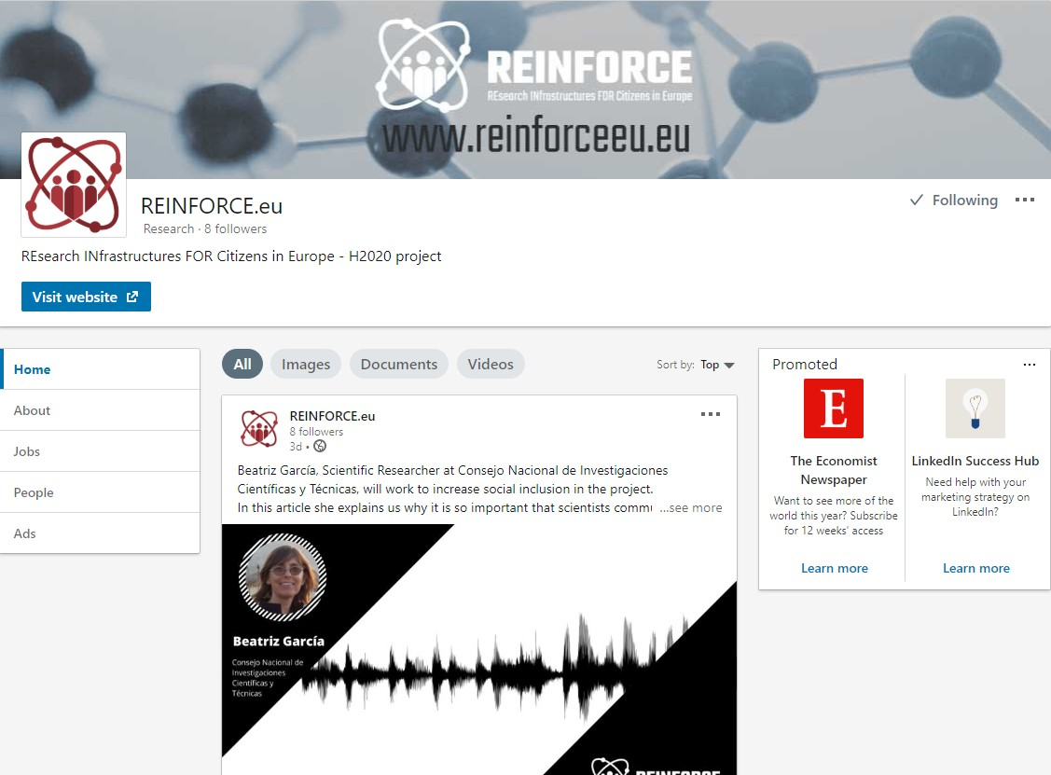
FIGURE 6 – REINFORCE LINKEDIN ACCOUNT
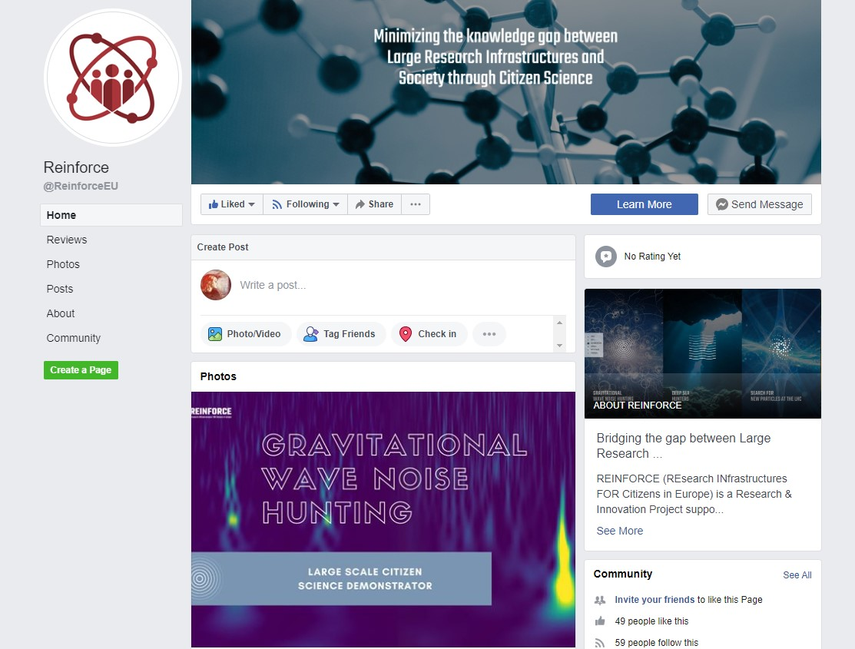
FIGURE 7 – REINFORCE FACEBOOK ACCOUNT

Twitter
Twitter is mainly used to provide brief real-time updates and news, but also as a tool to share generic information about citizen science, inform about the project, and promote event activities.
As of writing this document, the REINFORCE Twitter account has already constructed a solid base of XXX followers fitting several profiles: relevant Horizon 2020 projects related to citizen science, national associations working in citizen science, non-European projects about citizen science, scientists, researchers, consortium partners and official EC accounts. The REINFORCE Twitter account is intended to reach a broader audience and send out specifically tailored messages to different stakeholders on particular occasions.
So far, the REINFORCE Twitter account has been very active in engaging with different stakeholders with more than XXX tweets sent. We report some examples of the best performing tweets.
TABLE 1 – EXAMPLES OF TWEETS
Tweet | Results
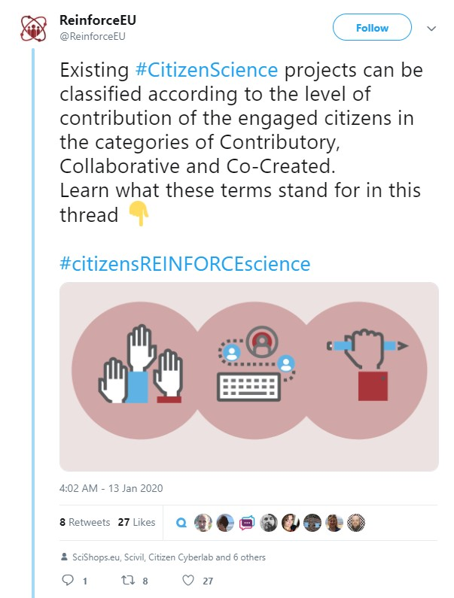 | Total impressions: 2,820  Total engagements: 73  - Likes: 27  - Media engagements: 16  - Profile clicks: 12  - Retweets: 8  - Detail expands: 5  - Hashtag clicks: 4  - Replies: 1
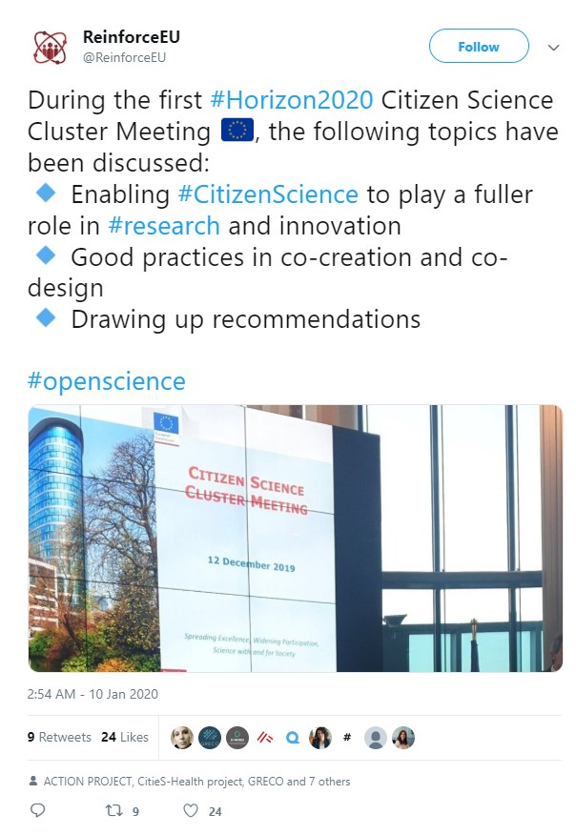 | Total impressions: 2,694  Total engagements: 51  - Likes: 24  - Retweets: 9  - Profile clicks: 7  - Media engagements: 5  - Detail expands: 5  - Hashtag clicks: 1
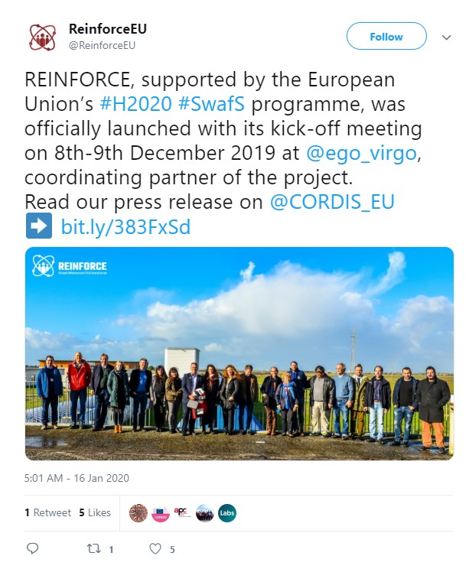 | Total impressions: 2,515  Total engagements: 28  - Media engagements: 10  - Likes: 5  - Link clicks: 5  - Detail expands: 4  - Profile clicks: 3  - Retweets: 1

LinkedIn
LinkedIn is mainly used to bring on board new relevant stakeholders and to reach the scientific and research community.

LinkedIn is also contextualised Social Network which gives the opportunity to introduce and promote research outcomes to a well-fit audience, to bring forward production and dissemination of scientific knowledge and find strategic partnerships.

At the time of writing the REINFORCE LinkedIn profile has made XX connections.
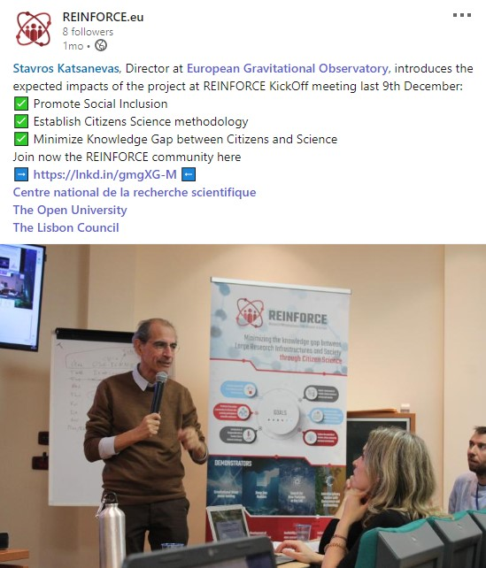
FIGURE 8 – EXAMPLE OF LINKEDIN POST

Facebook
Facebook is mainly used to bring on board new relevant stakeholders and to reach the broad public.
At the time of writing the REINFORCE Facebook profile has XX followers and XX likes.

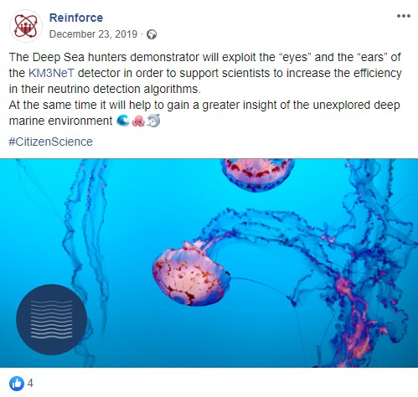
FIGURE 9 – EXAMPLE OF FACEBOOK POST

Poster
The usage of Poster as one of the key-asset for REINFORCE Communication Strategy combines multiple advantages:
- High efficiency with an affordable cost
- Versatility: posters can be displayed in a wide range of locations
- Encourage an active response (like during “Poster Sessions” at events/fairs)
- Flexible Design to appeal diverse kind of audience (possibility to leverage eye-catching graphic design, tailored written content or even QR code to drive people to the website)
A first poster was produced for the project at M2, to be shown at future events.
The poster focuses on REINFORCE main goals and highlights the four citizen science large-scale projects that will be carried out during REINFORCE lifespan. The poster includes also a brief introduction of the project, logos of the partners involved, official hashtag and a “call-to-action” to join the community through the website or social media channels.
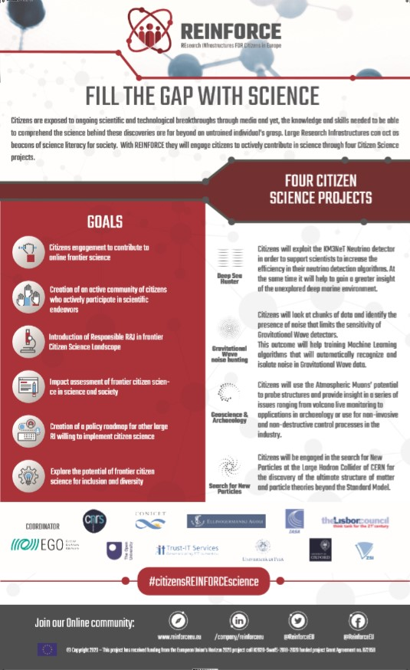
FIGURE 10 – POSTER
Four other posters will be done before M36.

Roll- up banner
Roll-Up Banners are an additional promotional tool that REINFORCE Consortium will leverage to support the Communication strategy of the project. Roll-Up Banner (or Pull-Up Banner) encompasses tangible multiple benefits as the following:
- High portability: Roll-Up banners are lightweight, designed to be easy to manage and moved around in different context (trade shows, fairs, exhibitions or simply stalled in offices)
- Easy installation and set-up
- Roll-Up Banner are reusable and long-lasting thanks to their laminated print (sustainable aspect is taken into account)
- Possibility to grab quickly attention and to provide content rich information to the viewers
- Suitable for outdoor as well as indoor environments
The branded project Roll-Up Banner provides a general overview of the project and has been already used at the kick-off meeting of the project.
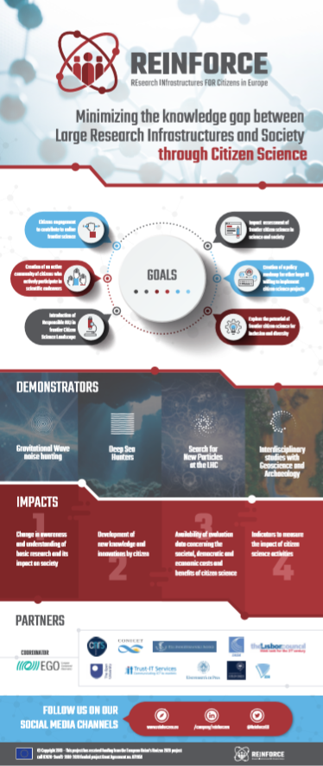
FIGURE 11 – ROLL-UP BANNER

Flyer and Brochure
Collaterals such Flyers and Brochures will help in building REINFORCE Visual Identity and implementing the dissemination and Stakeholder engagement strategy. Flyer and Brochures allow a fast promotion of the project and the opportunity to reach out to a wide audience both online and offline. Furthermore, they will be used to point out and bring to people’s attention the most relevant details of the project as well as to move people to interact with REINFORCE.
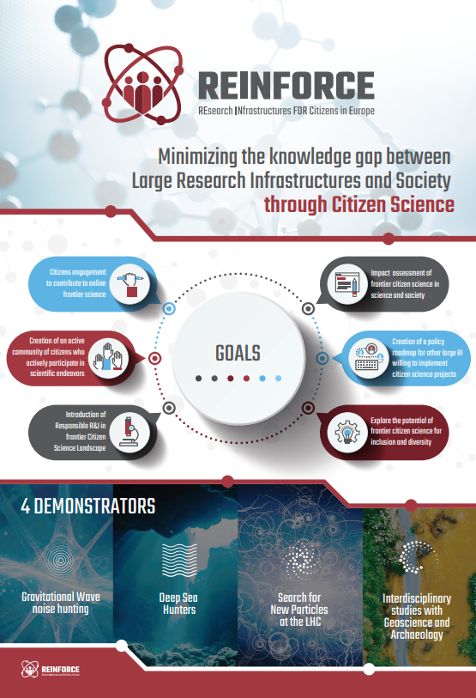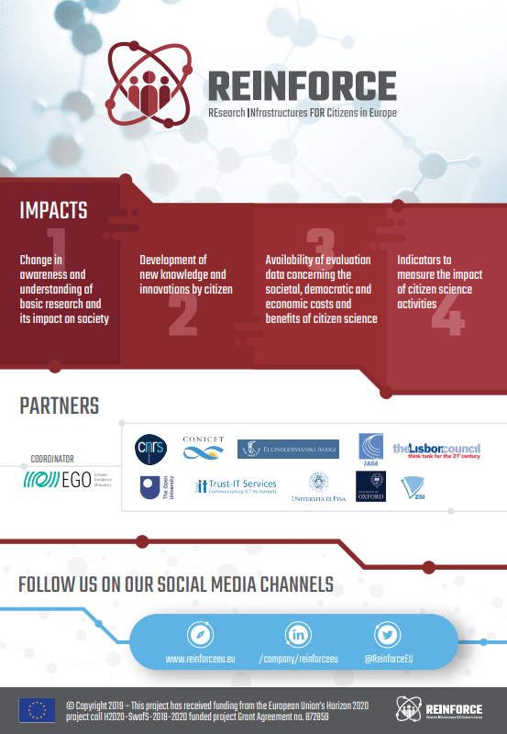
FIGURE 12 – FLYER COVER AND BACK COVER
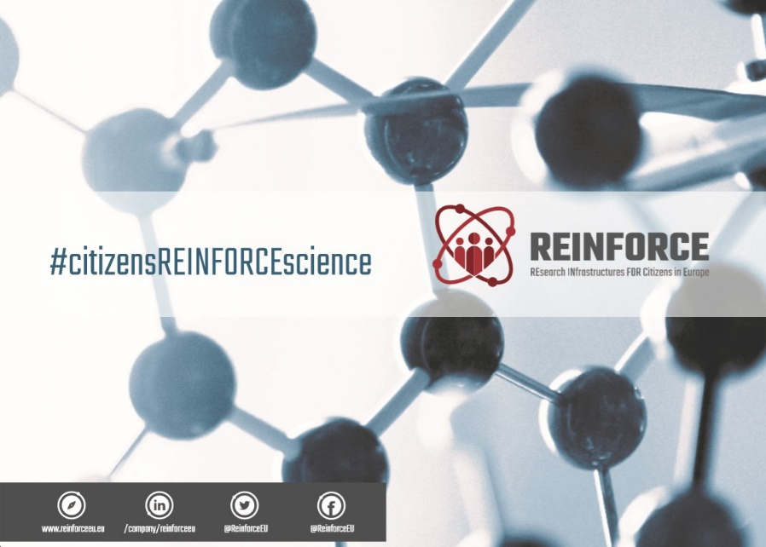
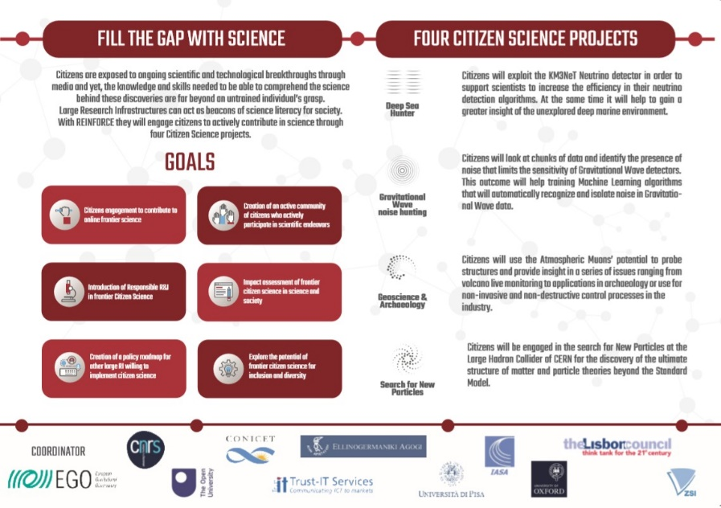
FIGURE 13 – BROCHURE

Press Release
The official start of the project was launched with the distribution of a Press Release (In M1) published through CORDIS, the Community Research and Development Information Service of the European Commission, to disseminate information on the project and its goal in the broadest sense.
Press Release was also promoted on Partners websites and through the European Physical Society platform.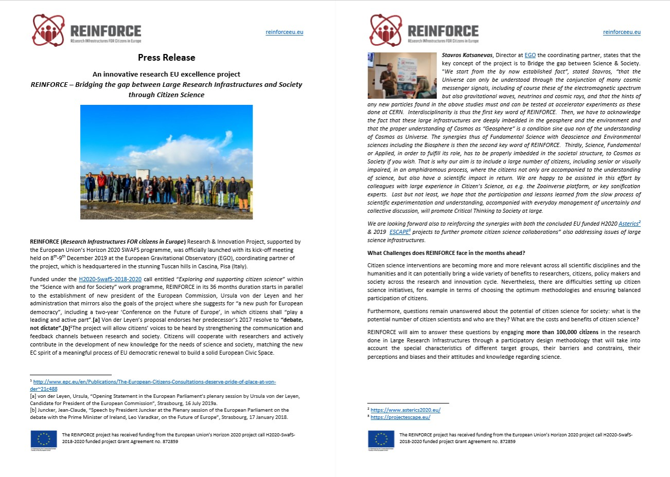
FIGURE 14 – PRESS RELEASE

Newsletter
Aimed at a general audience, a bi-monthly REINFORCE newsletter showcases project news, resources, the work of the citizen science community, highlighting the results of their transnational cooperation and the societal challenges they are addressing. The newsletter is coordinated by EA under WP8 and authored by the contribution of a different consortium member on a rotating basis.
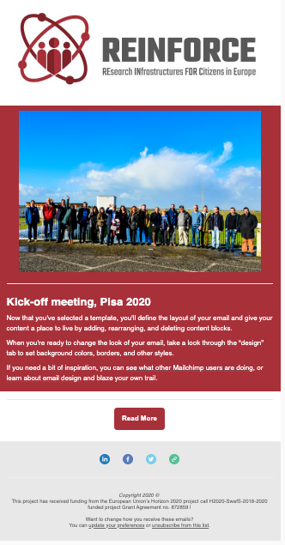
FIGURE 15 – NEWSLETTER TEMPLATE

Videos
A series of three video interviews has been produced, aiming to give a high-level overview of the project. The interviews feature Stavros Katsanevas, director of the European Gravitational Observatory, REINFORCE Project Coordinator; Emmanuel Chaniotakis, researcher at the RnD Department of Ellinogermaniki Agogi School, WP8 Leader; and Christine Kourkoumelis, professor of Physics at the University of Athens and member of IASA’s Directorate, WP5 Leader.
The videos are going to be used on REINFORCE’s social media and website.
TABLE 2 – VIDEOS
Title | Link
Interview with Stavros Katsanevas | https://youtu.be/0gJ0QWiJ3LY
Interview with Emmanuel Chaniotakis
Interview with Christine Kourkoumelis

Dissemination events
Events are profoundly instrumental in disseminating information about REINFORCE and engaging with various stakeholders and potential citizen scientists.
The list below includes events where REINFORCE representatives have participated and future events where the participation of REINFORCE is under discussion.
TABLE 3 – LIST OF EVENTS
Title | Date | Location | Organizer | Description
Horizon 2020 Citizen Science Cluster Meeting | 12/12/2019 | Brussels, Belgium | Research Executive Agency in cooperation with DG Research and Innovation | The event gathered every European project related to Citizen Science with a common aim to discuss the key outcomes, identify the difficulties and make some recommendations for the new Horizon Europe Programme to come.  Three workshops were covering areas of common interest:  - Challenges: Enabling citizen science to play a fuller role in research and innovation  - Good practices in co-creation and co-design  - Drawing up recommendations
Science in the City Festival | 5-9/07/2020 | Trieste, Italy | EuroScience Open Forum (ESOF) | The event is one of the largest public engagement in science and technology events in Europe. The participation of REINFORCE is being considered.
European Researchers' Night | 25/09/2020 |  | European Gravitational Observatory (EGO) | European Researchers’ Nights are public events dedicated to bringing researchers closer to the public, highlighting the impact of research on our daily lives.  EGO will organize some events as part of the initiative as it did in the last years.
IAUS 367: Education and Heritage in the Era of Big Data in Astronomy | 9-14/12/2020 | Bariloche, Argentina | International Astronomical Union (IAU) | The goal of the Symposium is to foster inclusiveness in the advancement of astronomy and facilitate the advancement of the next generation of astronomers and scientists, through encouragement of the use of new methods of learning and best practices in pedagogy at different education levels.  Beatriz García, WP7 leader, is directly involved in the organization of the event.

Conclusions
The dissemination of REINFORCE’ outputs has two paramount objectives:
- Making the knowledge developed throughout the project available to the widest audience (through public disclosure of project results).
- Enhancing its exploitation potential (more stakeholders involved in the process).
All the above-mentioned dissemination items and activities will serve the purpose to effectively address the target groups and to reflect a broad range of stakeholders of citizen science in order to ensure that several actors are kept continuously engaged in a two-way dialogue with the project at a local, national and EU level with the aim of raising awareness of citizen science and design among a broad segment of the public who currently does not identify them as a source of value.
The target groups for the dissemination activities are broken down into equally important categories, as follows:
- Citizen Scientists
- Scientific and Research community
- Broad Public
- Policy Makers (local, regional, national, European)
- Industry and Innovation
The dissemination activities and all the material developed so far are directed towards all these categories alike, implementing in every individual case various communication tools and channels.

