VirgoLab Organisation Proposal

Contacts: Rosemarie Aben, Ursula Bassler, Franco Carbognani, Viola Sordini

The Council of the European Gravitational Wave Observatory (EGO) put in place an Organisational Review of EGO and Virgo, with a report provided by the review committee in March 2024 including recommendations in seven relevant areas. Following this report, EGO Council mandated the Implementation Committee to follow-up on these recommendations.

The following proposal is taking up on the recommendations related to the Organisation and Governance of EGO/Virgo. In particular, it lays out the organisation of the detector operation, commissioning and upgrade of the Virgo interferometer as a distributed laboratory, called VirgoLab in the following, and specifies its governance. The creation of VirgoLab is inspired by LIGO Laboratory, the operating structure of the US gravitational wave antennas, yet taking into account the differences arising from the European funding structure and research landscape. VirgoLab is also meant to fit into and facilitate the transition from the Virgo Collaboration to IGWN.

The current draft document reflects the work in progress and is under construction. It addresses the definition of VirgoLab, the outlay of the organisational structure, the governance bodies and the management positions. An additional section laying out some procedures that will be necessary will be amended. The proposal is based on the current structure of the Virgo collaboration, yet the transition towards IGWN is laid out together with open questions summarised at the end of the document.

Definition of VirgoLab

1.1 Purpose
VirgoLab is mandated by the EGO Council for the production of calibrated, high-quality strain gravitational wave data, obtained with the Virgo Interferometer and to be provided to the Virgo Collaboration* with sensitivities and timelines comparable to the data of the LIGO gravitational wave observatories. VirgoLab operates in coherence with the other observatories of the LIGO-Virgo-KAGRA* scientific collaboration.

1.2 Organisation
VirgoLab is set up as a distributed laboratory to enable joint operation, commissioning and upgrades by EGO, and Virgo laboratories, institutes and university departments (referred to as External Labs). Personnel from both EGO and the External Labs participate in VirgoLab. VirgoLab is hosted by EGO and embedded into EGOs organisational structure. MoAs between EGO and the External Labs will specify the commitment from the External Labs to VirgoLab. These commitments can either be commitments for resources (financial as well as personnel working for VirgoLab for xx% of their time) or commitments to deliver (e.g. building equipment to be inserted into the interferometer). The organisational chart of VirgoLab, sketched by the Organisational Review Committee, is proposed to be implemented as a strong matrix organisation (see Appendix): Detector Upgrade, Operations and Commissioning are organised as VirgoLab Projects supported by VirgoLab Technical Teams (functional units) that focus on the core technical areas.

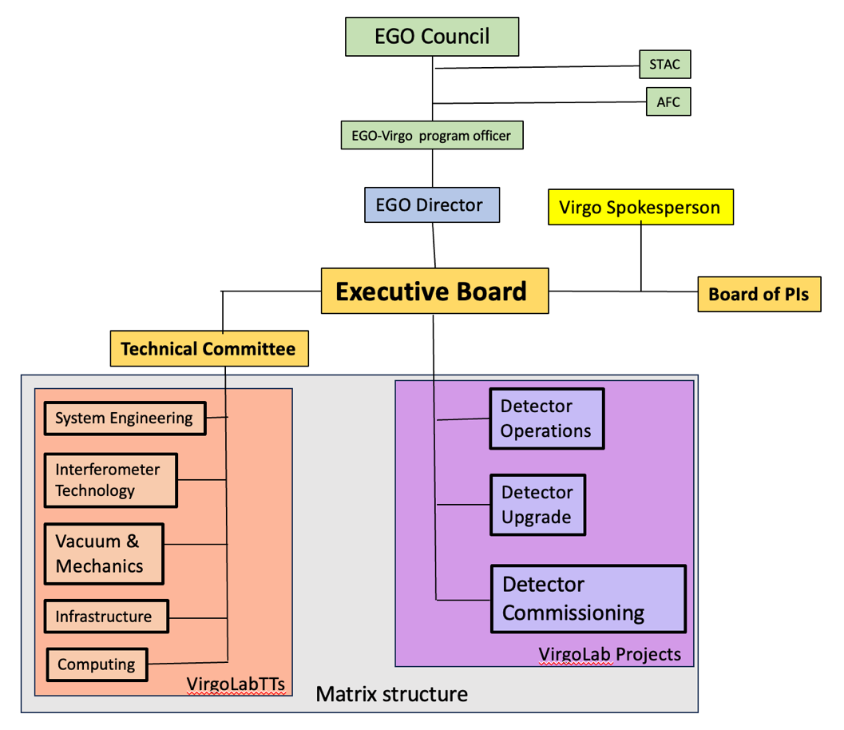
1.3 Resources
VirgoLab consists of cross-institutional VirgoLab Projects and VirgoLab Technical Teams with personnel from EGO and the External Labs.
Financial resources are allocated by EGO Council, national funding agencies or research organisations to EGO or to the External Labs.
The contributions of External Labs to VirgoLab are initially defined by a Memorandum of Agreement (MoA) between EGO and their home institution. The commitment of resources towards the various VirgoLab Members and the fulfilment of their mission are reviewed and updated annually after a resource review procedure, specified in a separate section 5.1.

Organisational structure of VirgoLab
The proposed matrix structure balances the functional responsibilities within each VirgoLab TT with the specific needs of each VirgoLab Project. It enables personnel to contribute their technical expertise to multiple projects while maintaining their development and long-term role in their functional area. The proposed structure implies some complexity and needs therefore be implemented in the most effective way. A question that arose about co-leadership for Project Coordinators and technical Team Leaders with people on-site and off-site should be addressed.

2.1 VirgoLab Projects (Project structure)
The core activities of VirgoLab are proposed to be organised around three major projects:

Detector Operations: Focused on the daily operations of the interferometer, ensuring smooth running and prompt troubleshooting if any issue arises. Operations include the production of calibrated, high-quality strain data as well as the computing infrastructure required to carry out strain data production.

Detector Upgrade: Responsible for planning and executing major upgrades to the interferometer’s systems, with a focus on improving sensitivity and performance.

Detector Commissioning: Manages the process of bringing new systems online, tuning the interferometer after upgrades or maintenance, and ensuring it meets the required operational standards.

This proposed structure will be presented to the Virgo Steering Committee (VSC) and to be approved by the EGO Council. Modifications to the project structure at a later stage are presented by the EGO director to the VirgoLab Board of PIs and approved by the EGO Council.

Each of these projects will be led by a Project Coordinator (i.e., Project Manager). The Project Coordinator will manage all aspects of the project, from planning and resource allocation to execution and delivery. These projects require collaboration across the VirgoLab Technical Teams, leveraging expertise and resources from each. The Project Coordinators will direct personnel on tasks related to project deliverables, deadlines, and milestones, in agreement with the MoA with the concerned External Labs. Personnel participating in a project will report to their Project Coordinator for project-specific work.

The Project Coordinators are proposed by the EGO Director, presented to the VirgoLab Board of PIs and approved by EGO Council.

The Project Coordinators are appointed by the EGO director for a renewable fixed term (same term as the EGO director). If a change should become necessary during the mandate of the EGO Director, the EGO Director will present the change to the Board of PIs and will seek approval from the EGO Council.

2.2 VirgoLab Technical Teams (Functional Structure)
The technical activities of VirgoLab are proposed to be based on functional units (VirgoLab technical teams - VirgoLab TTs) that will organise and support all technical activities related to the Virgo interferometer. The VirgoLab TTs will collaborate with the VirgoLab Projects to provide the necessary support for specific tasks.

While VirgoLab operates within the broader EGO structure, the VirgoLab TTs do not coincide with the established EGO departments and operate independently of the existing EGO departments, as they are distributed, cross-institutional teams, integrating personnel from EGO and from External Labs. This separation ensures that EGO’s standard organisational structure continues to play a key role in the VirgoLab activities, while enabling VirgoLab to draw on a wide range of expertise from across all External Labs in a flexible, project-oriented manner. Like External Labs, EGO can participate in other projects (e.g. ET activities), besides VirgoLab, with contribution from the EGO departments.

The proposed five VirgoLab TTs are:
- System Engineering: Oversees the overall system design and integration, including risk management and quality control, ensuring the coherence of all subsystems.
- Interferometer Technology: Focuses on the technical aspects of the interferometer, including optics, photonics, electronics and detector components.
- Vacuum & Mechanics: Responsible for the vacuum system and mechanical structures essential to Virgo’s operation.
- Infrastructure: Manages site-specific infrastructure, including buildings, power systems, and environmental controls.
- Information Technology: Handles Computing infrastructure, data management, software development, and cybersecurity.

This initial proposal for the VirgoLab TTs can be revisited as needed for efficient functioning.

The definition of workmanship standards will be a key responsibility of VirgoLab TTs, ensuring consistency, quality benchmarking, and risk reduction in project outputs. Those standards also form the foundation for training and skill development, guiding personnel to meet quality expectations and supporting continuous improvement in technical capabilities.

Each VirgoLab TT is headed by a Team Leader who will coordinate the functional expertise and resources of the team. The Team Leaders ensure that the defined workmanship standards are applied in all projects. The Team Leader will also be responsible, in collaboration with the home institution or EGO departments, for appropriate training and competence development of its members. Team Leaders are particularly in charge to ensure all means that allow members of the External Labs to contribute efficiently. The VirgoLab Team Leaders are appointed by the Executive Board (EB).

Each member of a VirgoLab TT will report to their Team Leader on their activities and for their technical development and skill training. This ensures that personnel receive the necessary resources and guidance from their technical area.

Governance bodies
VirgoLab has three high-level governance bodies:

Executive Board (EB) is responsible for making key decisions on all aspects of VirgoLab, in particular technical decisions, resource allocation, strategic priorities, and long-term planning, ensuring alignment across both functional and project-based activities.

Technical Committee (TC) provides technical guidance to the EB and the VirgoLab Projects. The TC ensures that technical challenges are addressed collaboratively and that resources are deployed effectively to meet project goals.

Board of VirgoLab PIs is in charge of the pledging, allocation and use of resources from their groups, and offers input on the VirgoLab strategy.

3.1 Executive board

3.1.1. Key responsibilities

The EB is in particular in charge of:

Operational and Upgrade Decisions: The EB takes all decisions concerning the operation, commissioning and upgrades of the Virgo interferometer.

Resource loading: The EB establishes the necessary resources for the projects and manages the available resources to reach the best performances of the Virgo Interferometer.

On-site equipment: The EB is responsible for all equipment in the Virgo Interferometer. It will take over the responsibility from the External Lab as soon as the equipment is inserted into the Virgo Interferometer.

3.1.2 Composition
The EB represents the operational and technical leadership of VirgoLab. Its membership includes:
- EGO Director (Chair)
- Upgrade Coordinator
- Commissioning Coordinator
- Detector Operation Coordinator
- Technical Coordinator (chair of the Technical Committee)
- Virgo Spokesperson*
- Chair of the Virgo Lab Board of PIs

The composition has to ensure that all aspects of Virgo’s operation and future upgrades are covered by the appropriate expertise. The members of the EB are on site on a regular basis, typically a few days a week and more if the situation requires it.

3.1.3 Meetings
The EB is chaired by the EGO Director, who calls the meetings, proposes the agenda and leads the discussions. The board meets typically on a weekly basis to assess and make critical decisions regarding both the day-to-day operations and the long-term upgrades of the interferometer. In case of critical and urgent matters, the EB meets as frequently as necessary.

3.1.4 Decision-Making
The EB is committed to striving for consensus in its decisions. In practice, this means that members will work collaboratively to find solutions that everyone can agree upon, leveraging the collective expertise of the board. In the event that the EB cannot reach consensus on a particular issue and no decision by means of discussion, including indicative votes, can be reached, the EGO Director has the final authority. This ensures that the board’s deliberations do not lead to operational delays or indecision, with the EGO Director empowered to make the necessary calls for the project's success.

3.1.5 Reporting
The EGO Director, in their capacity as chair of the Executive Board reports to the EGO Council on the decisions of the EB and the activities of VirgoLab. The members of the EB report the relevant decisions to the entities there are responsible for.

3.2 Technical Committee

3.2.1. Key Responsibilities
The TC is in particular in charge of:

Technical Advice: Review and recommend on technical proposals, system performance, and upgrade plans.

Risk Management: Assess and advise on technical risks and mitigation strategies.

Technical Coordination: Ensure effective collaboration between technical teams and VirgoLab Projects.

Oversight of Training and Safety procedures: Responsible for the adequate training and safety procedures to be in place.
Coordination TTs: Responsible for the coordination among the different VirgoLab TTs.

3.2.2. Composition
The TC consists of the VirgoLab Team Leaders and the Technical Coordinator, additional Experts are invited as needed. The Technical Coordinator is, in principle, appointed by the EB among the VirgoLab Team Leaders, and serves a chair of the TC.

3.2.3 Meetings
The TC is chaired by the Technical Coordinator, who calls the meetings, proposes the agenda and leads the discussions. The TC meets typically on a monthly basis, additional meetings can be scheduled as needed, in particular on request of the EB.

3.2.4 Decision-Making
The TC seeks consensus for the advice it provides, but all perspectives are presented to the EB in order to enrich its decisions. In case no consensus can be reached, the Technical Coordinator has the final authority. Final decision-making rests with the EB and the EGO Director.

3.2.5 Reporting
The TC reports directly to the EB, providing technical recommendations. Decisions taken by the EB or the TC are reported by the Team Leaders to their respective teams.

3.3 Board of PIs
3.3.1. Key responsibilities

The Board is in particular in charge of:

Resource Review Process: Receives an annual report given by the EGO director, in their capacity as chair of the EB, of the use of the resources provided by the External Labs to VirgoLab. It reviews the resource requested for the upcoming year and liaises with the funding institutions for pledges of resources to be provided from the External Labs to VirgoLab.

Membership: The Board of PIs is responsible for examining the participation of new groups to VirgoLab and oversees the establishment of the MoA between EGO and a new group.

Personnel Matters: The Board of PIs is represented in the search committee of the EGO director either through its chair or delegate.
In addition, the Board of PIs expresses its vision on a geographically balanced scientific representation in IGWN in advance of the selection of the IGWN Spokespersons.

While the Board of Virgo Lab PIs plays an important advisory role, it does not interfere with the operational chain of command. The EGO Director and Executive Board (EB) retain ultimate authority over operational and technical decisions. The board’s role is to provide informed input that can help shape these decisions.

3.3.2. Composition
The Board of PIs is the representation of the groups (i.e. External Labs and EGO) contributing to VirgoLab. The EGO Director and the Virgo spokesperson attend the meetings. The PIs are appointed by the group.

3.3.3 Meetings
The Board elects a chair who calls the meetings, proposes the agenda and leads the discussions. The Board of PIs typically meets three to four times a year.

3.3.4 Decision-Making
The Board of PIs strives for consensus in its decision-making. On matters such as the approval of the annual report, membership and personnel matters, as well as for the election of its chair, voting rules have to be put in place.

3.3.5 Reporting
While advisory in nature, the Board’s feedback is communicated to the EB through the Chair of PIs to ensure that the perspective of the External Labs is considered in strategic decisions. The board of VirgoLab PIs does not have decision-making authority over the operational activities of the Virgo Lab.

3.4 Other committees
VirgoLab would also benefit from the advice of committees already in place, in particular the Scientific and Technical Advisory Committee. The STAC provides periodic reviews of the scientific and technical aspects of EGO to the EGO Council. With the creation of VirgoLab, which will be the major scientific and technical activity of EGO, the STAC should be mandated to review the performance of VirgoLab. The STAC should assess if VirgoLab meets the scientific and technical milestones and even if EGO Council is its primary recipient, the relevant findings will also be made available to the VirgoLab EB.

4 Management Positions

4.1. EGO Director
The EGO Director holds the primary executive authority of EGO as defined in the EGO statute. They are therefore responsible for all activities conducted at the EGO site, ensuring that the Virgo interferometer meets its operational and technological goals. The EGO Director plays a key role in overseeing the organisation’s operations, ensuring the smooth execution of its scientific objectives, and liaising with external advisory bodies.

4.1.1. Key Responsibilities
In view of the organisation of VirgoLab, the EGO Director has the final authority on all decisions concerning the operation and maintenance of the Virgo interferometer. They take ultimate responsibility for the success or failure of Virgo’s mission, ensuring that both operational and technological objectives are met.

The EGO Director is the chair of the VirgoLab Executive Board (EB). In this function, they are in particular in charge of establishing a constructive technically driven and consensus-oriented discussion in order to take the strategic technical decisions within the EB. The EGO Director has a pivotal function between EGO Council, the Board of PIs and the Scientific Collaboration. They are in particular in charge together with the Council representatives, the Chair of the Board of PIs and the Scientific Spokesperson to leverage expertise and resources from the External Labs.

The EGO Director represents VirgoLab in the EGO Council and attends the VirgoLab Board of PIs as well in the scientific collaborations.

4.1.2 Mandate
The Director’s term is fixed and renewable once, with the renewal decision being taken by the EGO Council and in consultation with the Board of PIs.

4.1.3 Appointment
The EGO Director is appointed by the EGO Council after an international recruitment process operated by a search committee. This search committee includes representatives of the Board of PIs, of the scientific collaboration and the EGO Council. Selection criteria include leadership capacities, management skills, and expertise in gravitational wave science and interferometry.

4.1.4 Reporting
The EGO Director reports to the EGO Council. They attend EGO Council meetings. As chair of the VirgoLab EB, they attend the meetings of the Board of PIs.

4.2. EGO-Virgo Program Officer
The EGO-Virgo Program Officer should insure the liaison between EGO Council and the EGO director. Even though their responsibility is not only focused on VirgoLab, overseeing the activities of VirgoLab would be the major part of their mission.

4.2.1. Key Responsibilities
The Program Officer should act as a strong link between the EGO Council and the EGO director. The main mission of the Program Officer will be to follow the activities and decisions of the VirgoLab EB. The Program Officer will oversee the implementation of EGO Council decisions, in particular concerning VirgoLab. In case of difficulties, the Program Officer could be the first level of information and exchange, before calling EGO Council whenever necessary.

4.2.2 Mandate
The mandate of the Program Officer is defined by EGO Council.

4.2.3 Appointment
The Program Officer will be appointed by EGO Council. The person should have no involvement in the VirgoLab or associated scientific collaboration.

4.2.4 Reporting
The Program Officer exchanges on a weekly basis with the EGO director and reports to the EGO Council President.

5 Procedures

5.1 Election procedure for EGO Director
tbd

5.2 Resource Review Procedure

A possible outlay of the resource review procedure could look like the following:
The EGO Director, in their capacity as chair of the VirgoLab EB, will present an annual report on the use of the financial and human resources provided to EGO and to the External Labs and allocated to VirgoLab; a proposal for the resources for the coming year; and a forecast of the resources required for the next five years to the Board of PIs and, after examination by the STAC and the AFC, to the EGO Council for a final approval. The role of the PIs is to liaise with their funding body to secure the necessary resources, both financial and human, between presentation to the Board of PIs and final approval by the EGO Council. A document summarising the committed pledges of each group, will then be approved by EGO Council and is the basis of the commitment for the upcoming year.
In case of non-fulfilment of the pledges by a group, and after discussion with the PI concerned, the EGO Director may inform the concerned Council members or the funding agency representatives of the difficulties encountered in order to find a solution for the missed engagement.

5.3 Process for the admission of new groups
tbd

5.4 Publication process
tbd

6 Open matters

Topics to be addressed:
- What kind of entity is VirgoLab?
  - an EGO project with international contributions?
  - an international collaboration hosted by EGO?
- Who is the owner of the Virgo equipment at the different stages (during building, on site, after installation has finished)?
- How would external project reviews be organised? Who is the authority who can call them? The Executive Board? The Projects? The Council?
- What are the benefits of participating in VirgoLab with respect to authorship criteria in scientific collaborations?
- Are all groups providing personnel to VirgoLab represented in the EGO Council by their funding institution?
- What are the financial resources provided: wrt to the budget of EGO, wrt to the common fund? Who is managing these resources?
- The members of VirgoLab may want to publish results and developments of the Virgo detector. What will be the publication policy and the review process for such publications?
- How will the transition of the VSC, VEC and JEVCO in the VirgoLab structure take place ? The Virgo Collaboration bylaws will need to be modified, will the VSC vote on the modification as foreseen currently in the bylaws?

Transition from VirgoCollaboration/LVK-SC to IGWN

- Will the VirgoLab Board of PIs be put in place right away, or will the VSC take this role until the transition to IGWN?
- What will be the scientific representation in the EB/Board of PIs once IGWN is created?
- How will IGWN take into account the contributions made to VirgoLab with respect to the scientific publication?

Appendix:

Organizations structuring background

Functional Organization

The organization is grouped by area of specialization within different functional areas (electronics, mechanics, sys engineering, etc). In a functional organization, maximum power rests with the functional manager and the project manager’s role in decision making is minimal.
Advantages
- the career progression of the team member is fully owned by the functional manager.
- Team members report to only one supervisor, hence avoidance of conflicts in the chain of command.
- Similar resources are centralized, hence better synergy within groups
Disadvantages of functional organization;
- Preference for functional specialization, at the cost of the project
- No career path in project management
- Inadequate integration across different functional areas
- Conflict and rivalry between functional areas may impede communication
- No individual has full authority and responsibility for the project. No proper accountability for the project can be expected.
- Project manager has no authority

Projectized Organization
In projectized organization, all the work is considered as a project and the project manager has total control over the projects. Personnel are assigned to and report to a project manager.
Advantages
- Team members will be more committed to the project
- Availability of career paths within the project management stream
- More effective project related communication
Disadvantages
- When the project gets over, the team gets dismantled, hence lack of security leading short term commitments
- Duplication of facilities and job functions eg:- administrative officer for each project, HR coordinator for each project, etc.
- Less efficient use of resources. Project teams tend to hang on to resources both material and human, even after the need for them.

Matrix Organization
Matrix organization is a hybrid of both functional and projectized organization, trying to leverage the strength of both. The team members report to two figures, the project manager and the functional manager.
In a strong matrix, the power rests with the project manager. In a weak matrix, the power rests with the functional manager. In a balanced matrix, the power is shared between the project manager and the functional manager.
Advantages
More support from functional organizations
Allows for the sharing of diverse resources across multiple projects
Better horizontal and vertical communication (better than functional)
Disadvantages
More than one supervisor for project teams, leaving the team members between devil and deep sea, due to conflicts between the project manager and the functional manager
More complex to monitor and control, if it spans different locations
there is a potential for conflict between project managers and functional managers

Strong Matrix Organization
In the “strong“ - Matrix a project manager is selected to oversee the completion of the project across the various involved functional levels of the organization.
The project manager is ultimately responsible for the project‘s completion, has final say on major project decisions and controls most aspects of the project, including the assignment of functional personnel, what they do and when.
The functional managers maintain title over their respective personnel and have consultation rights.
Advantages
ensures a strong project focus by having a project manager who performs a coordinating and integrating role across functional areas

Problems With Matrix Organizations
Failure to understand the key principles and roles in the more complex matrix organizational environment
Distrust in organizational forms which are not based on „unity of command“
Apprehensions of functional managers over the apparent superiority of the project goals over those of the functional entity
Senior management shortcomings in terms of clearly delineating in writing the formal and reciprocal roles of all the key managers involved in the project
Inadequate stakeholder management

The advantages of (strong) Matrix organization largely overcome the listed problems as long as senior management is well aware of them and they are properly dealt with.

