VirgoLab Organisation
The Council of the European Gravitational Observatory (EGO) put in place an Organisational Review of EGO and Virgo, with a report provided by the review committee in March 2024, recommending the creation of VirgoLab.
This document addresses the Organisation put in place at VirgoLab. It is based on the “VirgoLab Organisation and Governance” document, endorsed by the EGO Council during its session on 19 March 2025. This initial document has been split into the “Framework Agreement for the Participation in VirgoLab” containing the description of the VirgoLab Governance, and two Annexes, the “VirgoLab Organisation”, and the “VirgoLab Rules of Procedure”.

Definition of VirgoLab

Purpose
VirgoLab, as a distributed laboratory, is put in place by the EGO Council to operate, maintain, commission and upgrade the Virgo interferometer to produce calibrated, high-quality strain gravitational wave data, to be provided to the Virgo Collaboration, in coordination with the LIGO and KAGRA Collaboration ((LVK Collaboration). The aim of VirgoLab is to ensure that the Virgo interferometer reaches sensitivities and produces observational data to be a cornerstone of the worldwide network of gravitational wave observatories. All members of VirgoLab are deeply committed to the purpose of VirgoLab and to the existence and operation of a gravitational wave interferometer in Europe. To fulfil its ambitious mission, VirgoLab requires steady and adequate financial support from its funding bodies.

The data analysis for research in the fields of fundamental physics of gravitation and astrophysics is carried out by the Virgo Collaboration. The Virgo Collaboration is in charge of the publication of scientific results. Scientists and engineers from VirgoLab are members of the Virgo Collaboration and can participate in the full range of its activities.

Organisation
VirgoLab is organised as a distributed laboratory with participations from EGO and the laboratories, institutes and university departments involved in the Virgo Collaboration, referred to as Member Labs. EGO, as the responsible legal entity, acts as a host Lab for VirgoLab in accordance with the EGO statutes.
The organisational chart of VirgoLab (Fig. 1), initially sketched by the Organisational Review Committee, is proposed to be implemented as a strong matrix organisation: Detector Upgrades, Operations and Commissioning are organised as phases of the VirgoLab Project supported by VirgoLab Technical Teams that focus on the core technical areas.

Organisational structure of VirgoLab
The proposed matrix structure balances the functional responsibilities within each VirgoLab TT with the specific needs of each VirgoLab Project. It enables personnel to contribute their technical expertise to multiple projects while maintaining their development and long-term role in their functional area.

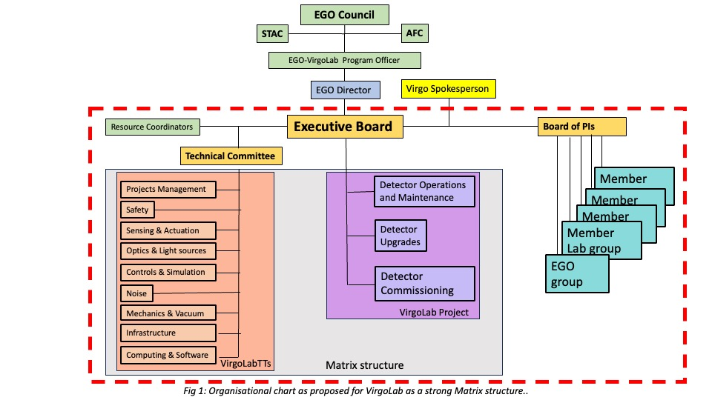
VirgoLab Project (Project structure)
The core activities of VirgoLab are proposed to be organised around one project with three phases:
Detector Operations and Maintenance: Focused on the daily operations of the interferometer, ensuring smooth running and prompt troubleshooting if any issue arises as well as the ordinary maintenance of all the installed subsystems. Operations include the production of calibrated, high-quality strain data as well as the computing infrastructure required to carry out strain data production. Provisionally, Detector Operation is supposed to include all activities in the current Operations Division (low latency, computing, detchar, calibration, open data…).

Detector Upgrades: Responsible for planning and executing major upgrades to the interferometer’s systems, with a focus on improving sensitivity and performance. Innovative long-term R&D is carried out in the scientific collaboration, guided by VirgoLab and becomes part of the Detector Upgrades project depending on its readiness level (e.g. as soon as the baseline design is being established - to be discussed). Detector Upgrades can be represented by one or two Project Coordinators in the EB, one for the current upgrade project, and one for the following one.

Detector Commissioning: Manages the process of bringing new systems online, tuning the interferometer after upgrades or maintenance, noise hunting, and ensuring the detector meets the required operational standards, and plan and execute minor upgrades necessary to reach these goals.

Modifications to the project structure are presented by the EGO director to the VirgoLab Board of PIs and approved by the EGO Council.

VirgoLab Technical Teams (Functional Structure)
The VirgoLab technical Teams (VirgoLab TTs) coordinate and support technical activities driven by the needs of the projects. The Virgo Lab TTs can be understood as overarching working-groups on technical subjects, fostering the exchange between the different Member Labs and EGO, as well as enhancing the underlying expertise and facilitating the cross-fertilization of technical aspects between the projects. The VirgoLab TTs are distributed, cross-institutional teams, integrating personnel from EGO and from Member Labs.

The structure of the VirgoLab TTs is elaborated by the Executive Board and presented to the VirgoLab Board of PIs and the EGO Council. Areas of activities proposed to be covered by the VirgoLab TTs have been initially defined as Project Management, Safety, Sensing & Actuation, Optics & Light sources, Controls & Simulations, Noise, Mechanics & Vacuum, Infrastructure, Computing & Software. Details are given in Annex A. Changes to the VirgoLab TT structure should be presented to the VirgoLab Board of PIs and the EGO Council.

The definition of workmanship standards will be a key responsibility of VirgoLab TTs, ensuring consistency, quality benchmarking, and risk reduction in project outputs. Those standards also form the foundation for training and skill development, guiding personnel to meet quality expectations and supporting continuous improvement in technical capabilities.

VirgoLab TTs will propose, generate and maintain technical guidelines and policies and supervise their application. They will provide technical advice to the EB, the VirgoLab Project and their system units. Technical Teams will promote standardization and collaboration between system units and help to find and advise on the distribution of resources. TT will supervise and promote the EGO safety culture in the system units through safety procedure, risk assessment and safety training. TT will assess technical risks and suggest mitigations actions, through reports to the Technical Committee.

VirgoLab members participating in a TT will report through the structure of the TT on their activities and for their technical development and skill training. This ensures that personnel receive the necessary resources and guidance from their technical area.

Modifications of VirgoLab Organisation
Modifications to the VirgoLab Organisation are decided by the VirgoLab Executive Board and presented to the EGO Council for information.

Annexes

Technical Teams

Technical Team Structure
The Technical Teams are open to any active members in the VirgoLab, and any recognized expect in the corresponding field.
Each Technical Team is headed by a Team Leader. The Team Leader is proposed by the Executive Board and is ratified by the VirgoLab Board of PIs. The Technical Team could suggest a list of names to the Executive Board.
The Technical Teams are coordinated by the Technical Committee. The Technical Committee is composed by the Technical Team Leaders and the Technical Committee Chair. Additional experts could be invited to meetings of the Technical Committee by the Technical Committee Chair.
The Technical Committee Chair is designated by the Technical Team Leaders. He calls the Technical Committee meetings, proposes the agenda and leads the discussions. He is a member of the Executive Board.
Any changes to the Technical Team structures—including the creation or closure of a Technical Team—will require feedback from the VirgoLab Board of PIs, approval by the Executive Board, and presentation to both the VirgoLab Board of PIs and the EGO Council.

Technical Team Responsibilities
Technical Teams are responsible to ensure that Guidelines and Policies are followed. In particular, they are responsible for ensuring that all necessary means are in place to enable members of the Member Labs to contribute effectively. Specifically, the Technical Team responsibilities are:
- Provide technical advises to the Executive Board, VirgoLab Projects and/or System Units.
- Propose, create and maintain Guidelines and Policies and supervise their application.
- Provide training and competence development to its members.
- Promote standardization of technical solutions across VirgoLab.
- Promote the collaboration between System Units and Technical Teams.
- Help the System Units and/or the VirgoLab Projects to find and distribute resources and expertise.
- Supervise and promote a culture of safety across VirgoLab, including safety procedures, risk assessments, and safety training.
- Assess and advise on technical risks and mitigation strategies through reports to the Technical Committee.

Technical Committee Responsibilities
The Technical Committee Responsibilities are:
- Coordinate the work of the Technical Teams.
- Discuss and define deliverables for the Technical Teams, based on the requirements from the VirgoLab Projects.
- Review Technical Teams work and deliverables.
- Provide technical advice to the Executive Board and/or to the VirgoLab Projects.
- Promote standardization of technical solutions across the Technical Teams and System Units.
- Promote collaboration across Technical Teams.
- Assess and advise on technical risks and mitigation strategies, reporting to the Executive Board and to the VirgoLab Projects.
- Propose changes, creation or closure of any Technical Team to the Executive Board.

A.4 Working structure

A.4.1 Guidelines
Guidelines are a set of recommendations, advice, or best practices intended to provide direction.
The Technical Committee oversees the creation, amendment and application of the Guidelines across the Technical Teams.
The Executive Board, the VirgoLab Project Coordinators, the Technical Committee, the Technical Team Leaders or the System Unit Managers can propose the creation of a new Guideline, or the amendment of an existing Guideline.
The Executive Board, the VirgoLab Project Coordinators or the Technical Committee can request the creation of a new Guideline, or the amendment of an existing Guideline.
Requests or proposals to create or amend a Guideline are discussed by the Technical Committee.
The Technical Committee may request negotiations with the requesting body (Executive Board or VirgoLab Projects) regarding the creation or amendment of a Guideline, providing a reasoned justification.
A proposal to create or to amend a Guideline may be rejected by the Technical Committee, with the rationale for the rejection provided to the requesting body (Executive Board or VirgoLab Projects).
A new Guideline or the amendment of an existing Guideline is approved by the Technical Committee and by the requesting or proposing body (Executive Board or VirgoLab Projects).

A.4.2 Policies
Policies are a formal statement of rules or principles that must be followed.
The Technical Committee oversee the creation, amendment and application of the Policies across the Technical Teams.
The Executive Board, the VirgoLab Project Coordinators or Technical Committee can propose the creation or amendment of a Policy. The Executive Board can request the creation or amendment of a Policy.
The request or the proposal for the creation or amendment of a Policy is discussed by the Technical Committee.
The Technical Committee may request negotiations with the Executive Board regarding the creation or amendment of a Policy, providing a reasoned justification.
A proposal to create or to amend a Policy may be rejected by the Technical Committee with the rationale for the rejection provided to the requesting body (Executive Board or Projects).
A new Policy or the amendment of an existing Policy is approved by the Technical Committee, by the VirgoLab Projects and by the Executive Board.

A.4.3 Plan of Action
Technical Committee or the VirgoLab Projects can raise a critical issue and, eventually, propose a Plan of Action to the Executive Board, in order to solve or mitigate it.
The Executive Board can request a Plan of Action to the Technical Committee or to the VirgoLab Projects in order to resolve or mitigate a critical issue.
The Executive Board reviews and may request changes to a proposed Plan of Action.
The Executive Board can issue a proposed Plan of Action to the Technical Committee or to the VirgoLab Projects.
The Technical Committee or the VirgoLab Projects distribute and coordinate the work of a Plan of Action, monitoring the progress and reporting periodically to the Executive Board.

A.4.4 Major Technical Advice
The Executive Board or the VirgoLab Projects can request the Technical Committee to provide a Major Technical Advice regarding a complex technical problem, a major upgrade, etc.
The Technical Committee creates a plan and distributes the work across the Technical Teams, coordinates its progress and collects all the options with the related information (Risk, Cost, Benefit, etc.).
The Technical Committee discusses and reviews the available options and provides a Major Technical Advice Report. The Advice Report must include all the options discussed with all the related information for each of them, indicating their benefits and drawbacks. Preferred options could be indicated with a motivated reason.
The Major Technical Advice Report is provided to the requesting body (Executive Board or Projects) by the Technical Committee Chair.

A.4.5 Minor Technical Question
Each body in the VirgoLab (Projects, System Unit, etc) can request a Minor Technical Advice to a Technical Team.
The Technical Team reviews the request, prioritises the work, and accepts it or rejects it with a motivated reason.
The Technical Team creates a plan, distributes and coordinates the work, and collects all the options with the related information (Risk, Cost, Benefit, etc.).
The Technical Team discusses and reviews the available options and provides an Advice Report. The Minor Technical Advice Report must include all the options discussed with all the related information for each of them, indicating their benefits and drawbacks. Preferred options could be indicated with a motivated reason.
The Technical Team Leader reports the Minor Technical Advice Report to the requesting body (Projects, System Unit, etc).

A.4.6 Decision Power
Each Technical Team has authority on decisions that have no impact on other Technical Teams, nor negative impact on the Projects.
The Technical Committee has authority on decisions that have no negative impact on the Projects.
The Technical Team and the Technical Committee are committed to striving for consensus in their decisions. If consensus cannot be reached, respectively the Technical Team Leader or the Technical Committee Chair has the final authority.

A.4.7 Technical Team Members
The Technical Team members must be active members of VirgoLab, or well-known expert in corresponding fields.
The Technical Team Leader must be an active member of VirgoLab, with at least five years of experience in the corresponding fields.
The Projects, the Executive Board or the Technical Committee can request a VirgoLab body (VirgoLab Projects, System Unit, etc) to have one of their members join a Technical Team.

A.5 Transition Phase
The protoEB appoints the Interim Technical Team Leaders and the Interim Technical Committee Chair.
The Interim Technical Committee Chair organizes the first Technical Committee and coordinates the definition of the initial Technical Team Procedures.
The Interim Technical Team Leaders contact the System Units and organize the first Technical Team meetings to define the deliverables.
At the end of the Transition Phase (one year), each Technical Team proposes a list of possible Technical Team Leaders to the Executive Board.
After the new Technical Team Leaders are appointed, the Technical Team Leaders appoint the new Technical Committee Chair.

A.6 List of the initial Technical Teams

A.6.1 Project Management
Expertise on Project management, the overall system design and integration, including risk management and quality control, ensuring the coherence of procedures for all System Units.

A.6.2 Safety
Defines Policies and safety procedures with the related Technical Team(s). Oversees the legal requirement of the safety across VirgoLab, including mandatory safety training and certification, hardware safety certification, etc.

A.6.3 Sensing & Actuation
Technical aspects of sensors and actuators made in VirgoLab (TCS, ring heater, etc.), including the associated analogue electronics and cabling.

A.6.4 Optics & Light Source
Technical aspects of optics, crystals, coatings, lasers, other light sources, and physical optics simulations.

A.6.5 Controls & Simulation
Technical aspects of optical and mechanical plant simulation, controls of opto-mechanical plants, and the digital infrastructure or analogue hardware implementing the controls (DAQ, MPC, etc) , detector calibration.

A.6.6 Noise
Detector characterization noise studies, environmental noise hunting, theoretical noise budget (GWINC) and the measured interferometer noise budget, technical noise reviews, detector calibration.

A.6.7 Mechanics & Vacuum
Technical aspects of vacuum system, suspensions, optical benches and other large mechanical parts, and their finite-element simulation.

A.6.8 Infrastructure
The Virgo detector infrastructure including buildings, power systems and environmental controls, and the mitigation of noises produced by this infrastructure.

A.6.9 Computing & Software
Computing infrastructure, low-latency infrastructure, online pipelines, data management, software development and operation, data visualization and cybersecurity.

